**CHAPTER 1**

**INTRODUCTION**

* 1. **ABOUT THE DOMAIN**

The domain of this project is rooted in Artificial Intelligence, specifically the critical subfield of Natural Language Processing is a broad area of computer science focused on building machines that can mimic human intelligence to perform tasks like learning, reasoning, and problem-solving. Our work is a perfect example of applied , as it creates an intelligent system—the Voice Assistant—that can interact with people naturally. This is what makes possible. is the technology that bridges the gap between how humans communicate (using speech and text) and how computers process information (using data and code).

NLP involves several complex steps to make a voice assistant work. First, Speech-to-Text converts spoken words into a text format the computer can read. Then, the algorithms analyze this text to figure out the user's intent, grammar, and meaning. Finally, Text-to-Speech allows the computer to respond by generating human-like spoken language. This entire process is essential for creating tools like virtual assistants (Siri, Alexa), translation services, and the sophisticated chatbots we use every day. In our project, we leverage this technology to not just understand an answer, but to evaluate its quality for an interview context.

The value of this domain lies in its ability to provide objective, scalable solutions to real-world communication and analysis challenges. By using and to analyze interview responses, our system moves beyond subjective human judgment, offering consistent and detailed feedback on things like speech clarity and answer relevance. This application of directly contributes to the training and education sector, preparing individuals for high-stakes professional situations by using advanced computational power to simulate and score human interaction.

* 1. **ABOUT THE PROJECT**

The AI Interview Voice Assistant is a modern, interactive system designed to help users effectively prepare for job interviews. This project creates a realistic practice environment by using voice technology to simulate an actual conversation. Instead of just reading questions from a screen, the system uses Text-to-Speech () to speak the interview questions out loud, just like a human interviewer would.

When the user gives their answer, the system listens and uses Speech-to-Text to instantly convert the spoken words into written text. The real intelligence of the project lies in the Natural Language Processing Analysis Module. This module doesn't just check if the words are correct; it deeply evaluates the quality of the response based on three key areas: content relevance (is the answer related to the question?), clarity and structure (is the response easy to understand, and communication confidence (by analysing speech patterns and filler words).

After the session, the assistant generates a detailed performance report with scores and personalized suggestions. This report gives the user objective, data-driven feedback on exactly where they need to improve their communication and preparation, ensuring they are ready and confident for their real interview.

* + 1. **LITERATURE SURVEY**

Right now, many job seekers use computer tools to help them practice for interviews. These tools usually fall into two groups. The first group is for writing (like tools that check your answers on a screen). They are good for fixing *what* you say, but they cannot tell you how you sound. The second group uses video (like systems that companies use for hiring). These can check your body language and voice, but they are often complex and not designed just for quick, friendly practice. Because of these limits, there is a big missing piece: an easy tool that focuses only on making your voice sound confident and clear in a real-time conversation.

Our project, the Interview Voice Assistant, solves this by using special voice technology. First, we use Speech-to-Text () technology (like the kind in phone assistants) to quickly turn your spoken words into written text. This text is then ready for analysis. The most important part is Prosody Analysis. This looks at features of your voice, like how fast you talk , how high or low your voice is , and where you stop (). By checking these voice patterns, the system can objectively figure out if you sound or .

After we analyze the voice, we use Natural Language Processing to give you clear feedback. One key use of is finding and counting Filler Words (like "um," "uh," and "you know"). Too many filler words hurt your score because they make you sound unprepared. also makes sure your answer is relevant by comparing your words to the question's topic . Finally, the system combines all the data—your confidence level, your pace, your filler count, and your content—to create a simple, actionable report. This report tells you exactly how to improve your speaking style to succeed in your real interview.

**CHAPTER 2**

**PROBLEM DEFINITION AND FEASIBILITY ANALYSIS**

**2.1 PROBLEM DEFINITION:**

Many job seekers, particularly those fresh out of school or moving to a new field, struggle significantly with interview preparation. While their technical and professional knowledge might be strong, they often lack the opportunity for realistic, real-time practice that truly mirrors a job interview setting. The core issue is that traditional study methods, such as reading guides or rehearsing alone, fail to replicate the pressure and dynamic flow of a live conversation. This creates a critical "real-time confidence gap."

During actual interviews, candidates frequently exhibit critical communication flaws, such as speaking too fast or too slowly, using unclear articulation, or excessively relying on filler words like "um" or "like." More importantly, they lack a source of instant, objective feedback on crucial non-verbal aspects like their tone, perceived confidence, and the structural coherence of their answers. Since human practice partners are often unavailable or may provide inconsistent, subjective advice, this lack of real-time, unbiased assessment prevents otherwise qualified candidates from performing at their best.

This high-anxiety situation and the resulting poorly structured responses lead directly to missed career opportunities, despite the candidate possessing the necessary qualifications. Therefore, an AI-based voice assistant is urgently needed to provide a consistent, personalized, and effective solution to bridge this confidence gap by offering a safe, real-time environment to practice and receive actionable feedback on both *what* they say and how they say it process difficult to scale.

Furthermore, it is a time-consuming process with delayed feedback, often forcing candidates to wait for days to get results. Crucially, these manual methods suffer from a lack of personalized, data-driven insights, as feedback tends to be subjective and non-quantifiable. Finally, accessibility is often restricted to physical or scheduled sessions, preventing candidates from practicing spontaneously or frequently when they need it most.

**2.1.1 EXISTING SYSTEM**

Traditional practice often involves a peer, friend, or mentor acting as the interviewer. While this provides a human connection, the feedback is highly subjective and depends entirely on the interviewer's experience and biases. It can also be expensive and difficult to schedule enough practice sessions to feel truly prepared. This method is inconsistent and often focuses more on the *content* of the answer rather than the *way* it is delivered.

On the other hand, many current digital and AI systems are too basic. They may offer pre-set questions or simple text-based answers, which do not create a realistic interview environment. These tools usually provide limited analysis, perhaps only counting filler words. They lack the ability to give detailed, real-time feedback on critical delivery elements, such as your speaking pace, tone of voice, and body language, which are vital for showing confidence and communication skills.

**2.1.2 PROBLEM IDENTIFICATION**

The primary problem with existing interview preparation is the lack of a comprehensive, objective, and scalable feedback mechanism for a candidate's non-verbal and para-verbal communication. Traditional mock interviews rely on subjective human judgment, which is inconsistent and often fails to provide granular data on critical performance factors like vocal prosody (pitch, tone, and volume variation), speaking pace, and the exact frequency of filler words ("um," "like," "so"). Furthermore, current digital tools offer only superficial analysis, making the practice unrealistic. Candidates may feel prepared with their answers (the content), but they often remain unaware of critical flaws in their delivery—the way they sound and carry themselves.

This failure to address delivery leaves candidates prone to performance anxiety and underperformance in the actual high-stakes interview setting, where confident, clear communication is just as important as technical knowledge. This systemic gap results in a core problem: candidates can't accurately measure their presentation skills and pinpoint the specific vocal and behavioral weaknesses they need to fix, limiting their ability to truly master the interview format.

**2.1.3 PROPOSED SYSTEM**

The proposed system is an Advanced AI Mock Interview Platform designed to overcome the limitations of existing methods by focusing on objective, real-time analysis of communication delivery. It will utilize sophisticated AI to conduct highly realistic, conversational mock interviews, serving as a dynamic and scalable coach.

The core feature will be a comprehensive Delivery Assessment Model. This model won't just count filler words; it will analyze a candidate's vocal prosody (tone, pitch, volume, and emotion) and speaking pace in real-time, providing immediate feedback overlays. It will also track non-verbal cues via video, such as eye contact and facial expressions, offering a holistic view of the candidate’s confidence and engagement. The system will feature a dynamic question generator that adapts follow-up questions based on both the *content* and the delivery of the previous response, simulating an authentic, high-pressure interview scenario. This platform will provide detailed, quantifiable reports after each session, allowing candidates to track progress and target specific, measurable improvements in their presentation skills.

**2.2 FEASIBILITY ANALYSIS:**

A thorough feasibility analysis was conducted to determine the viability of developing the AI Interview Assistant project. This analysis examines the system's potential success across operational, technical, and economical criteria, confirming that the proposed solution is practical, realistic, and achievable within the project constraints.

The findings indicate strong viability in all key areas. The necessary AI technologies are mature, development costs are manageable against the market need, and the system design aligns perfectly with user demands for flexible, high-quality practice.

**2.2.1 OPERATIONAL FEASIBILITY**

The proposed system is highly feasible to operate. It is designed to directly solve the widespread and ongoing user need for objective and consistent job interview practice. By creating a web-based platform, we ensure that the system is intuitive and easy to use, requiring minimal setup—only a standard microphone and any modern web browser.

This simplicity guarantees high user acceptance. Candidates are strongly motivated to adopt the system because it offers clear benefits: objective, data-driven feedback on their speaking style and delivery, combined with 24/7 accessibility. This means a user can practice anytime, anywhere, fitting seamlessly into their busy self-study schedule. The system integrates easily into a candidate's existing routine without needing new hardware or complex training. Its straightforward design and compelling benefits make it operationally viable for immediate rollout and widespread adoption.

**2.2.2 TECHNICAL FEASIBILITY**

The project is economically feasible because the costs for development and deployment are justified by the significant market demand and the system's strong revenue potential. Development costs are kept manageable by leveraging existing, affordable AI APIs and open-source frameworks, avoiding the high expense of building proprietary models from scratch.

The system's subscription-based model ensures a reliable and scalable stream of revenue. It offers a much more cost-effective and superior alternative to expensive, time-consuming human coaching services. Given the large and growing market of job seekers needing high-quality interview practice, the platform's ability to offer 24/7, consistent, and objective analysis positions it for a rapid return on investment (ROI) and long-term financial viability.

**2.2.3 ECONOMICAL FEASIBILITY**

The project is considered economically feasible and a sound investment, particularly as a mini-project. Since the system is built using widely available and often open-source tools and frameworks (like Python and standard web technologies), the major development cost is kept low.

The main expenditure is the time and effort of the development team, rather than high licensing fees for proprietary software or expensive infrastructure. manageable and justifiable for proving the system's concept. This efficient use of resources makes the platform.

**CHAPTER 3**

**SOFTWARE REQUIREMENTS SPECIFICATION**

**3.1 INTRODUCTION**

The AI Interview Assistant is a cutting-edge software application designed to help job seekers significantly improve their performance in technical and HR interviews. The core problem this system addresses is the lack of objective, realistic feedback available during solo interview practice.

This project leverages Artificial Intelligence (AI) and Natural Language Processing (NLP) to simulate a live interview experience. Users speak their answers, and the system instantly analyzes their response content and delivery style. Key functionalities include Speech-to-Text (S2T) transcription, semantic analysis for content relevance, and assessment of delivery confidence (by tracking filler words and speech rate). By providing detailed, data-driven reports, the AI Interview Assistant allows users to pinpoint weak areas in their communication and knowledge, ensuring they are well-prepared to secure employment. It serves as a personal, always-available career coach, making effective interview practice accessible and efficient.

**3.2 REQUIREMENT ANALYSIS**

Requirement analysis is a critical, early step in developing the AI Interview Assistant. This stage defines exactly what the system must achieve and the conditions under which it needs to operate. It's essentially the blueprint that ensures the final application successfully meets the real needs of job seekers, stays aligned with our project goals, and can be built effectively using available resources like AI tools and programming languages. By carefully identifying all functional requirements (what the system does), non-functional requirements (how well it does it), and any system limitations, this analysis helps us minimize risks such as miscommunication, unnecessary feature creep, and, ultimately, project failure.

The analysis for the AI Interview Assistant involved first studying existing interview preparation methods. We looked at simple mock interviews and existing online tools to understand where they fall short. We found a major gap: they often fail to give objective, data-driven feedback on *how* a person speaks, focusing only on the *content* of the answer. Our goal was to map this unmet user need to our technical capabilities, focusing on voice recognition and advanced language analysis. This deep understanding ensures our proposed system is truly innovative and solves a genuine problem for users.

Our requirement analysis was structured by examining the system from three distinct perspectives:

**User Perspective**

The end-users (job seekers) need an interview practice tool that is simple, reliable, and easy to access.

* Simplicity: The interface must be intuitive, allowing users to start a session, speak their answers, and view reports without needing any prior technical knowledge.
* Actionable Feedback: Users expect the system to provide specific, practical advice—not just a score—on *why* their answer was weak (e.g., "reduce filler words" or "increase detail").
* Privacy and Security: Users need assurance that their recorded voice, transcribed answers, and personal login data are handled with the highest level of security and confidentiality.

**System Perspective**

The core technology must be powerful and accurate to deliver value.

* High-Quality Voice Processing: The system must efficiently use Speech-to-Text (S2T) services (like Whisper) to convert spoken answers into accurate, clean text for analysis, even with minor background noise.
* Real-Time NLP: It must perform immediate Natural Language Processing to accurately calculate scores for Relevance (semantic comparison), Clarity (readability), and Confidence (filler word detection) without noticeable lag.
* Reporting: The system must generate a detailed, persistent report after every session, allowing the user to track their improvement over time.
* Cross-Platform Performance: The web application must maintain fast, smooth performance across various devices, including laptops, desktops, and mobile browsers.

**Developer/Stakeholder Perspective**

From the viewpoint of those building and owning the project, the system must be sound for future growth.

* Scalability: The architecture must be modular and designed to easily handle future increases in user traffic and data volume without major re-engineering.
* Maintainability: The code must be well-structured and documented so that developers can quickly debug issues or integrate future enhancements (like video or emotional analysis).
* Cost-Effectiveness and Reliability: The chosen technologies (e.g., Python, specific cloud APIs) must be balanced to ensure the system is affordable to run while remaining highly reliable and available to users 24/7.

By addressing these three perspectives, the requirements for the AI Interview Assistant are firmly centered on providing AI-driven, personalized voice analysis and secure data handling, ensuring a practical and impactful solution for every job seeker.

**3.2.1 PURPOSE**

The primary purpose of the AI Interview Assistant is to function as an intelligent, automated career coach that helps users master job interview skills. It aims to make interview preparation more accessible, effective, and data-driven by offering objective, reliable feedback that mimics human recruiter assessment.

The system’s core goal is to enable users to:

* Analyze Performance: Move beyond subjective self-assessment by providing quantifiable scores for various communication metrics.
* Identify Weaknesses: Pinpoint specific areas needing improvement, such as insufficient content, poor verbal clarity, or low confidence signaled by excessive filler words.

**Key Points and Uses**:

* **Simulate Realistic Interviews:** Creates an environment where users must provide spoken, real-time answers, preparing them for the actual pressure of an interview.
* **Voice-to-Text Accuracy:** Uses advanced Speech-to-Text (S2T) to reliably convert spoken responses into text, ensuring the analysis is based on what was actually said.
* **Content Relevance Scoring:** Measures how well the substance of the user’s answer aligns with the question asked, addressing the "what" of communication.
* **Confidence & Clarity Feedback:** Provides actionable insights on delivery style, focusing on the "how" of communication (e.g., speech rate, filler word count).
* **Track Improvement:** Generates persistent, detailed reports that allow users to monitor their progress and focus their practice efforts over multiple sessions.
* **Boost Employability:** Ultimately, the system aims to enhance the user's verbal presentation and content delivery, increasing their confidence and chances of success in the job market.

**3.2.2 SCOPE**

The scope of the AI Interview Assistant project defines the system's precise boundaries, detailing what it includes and, just as importantly, what it does not. It is designed to be a comprehensive, end-to-end voice-driven interview enhancement platform.

Inclusions (What the System Does):

* **Voice-Based Interface:** Provides a system accessible via any modern web browser that captures user answers through a microphone.
* **Secure User Management**: Features secure registration, login, and data storage to protect user profiles and session history.
* **Speech-to-Text (S2T) & Text-to-Speech (TTS):** Integrates reliable S2T services (like Whisper) to transcribe spoken answers and TTS to read questions aloud.
* **Core NLP Analysis:** Utilizes algorithms (e.g., semantic comparison, filler word counting) to calculate three essential scores: Relevance, Clarity, and Confidence.
* Detailed Reporting: Generates persistent, downloadable reports after each session, showing scores, transcribed text, and actionable improvement suggestions.
* Question Bank Management: Allows administrators or users to add, edit, and categorize the library of interview questions.
* Data Security: Implements strong security protocols, including password hashing, to ensure user data and voice recordings are confidential.

### **3.2.3 OVERVIEW**

The AI Interview Assistant is built upon a robust three-tier client-server architecture to ensure reliability and performance. This modular design separates the system into distinct layers:

1. **Presentation Layer (Frontend):** This layer is the web-based User Interface, accessible via any standard browser. It handles user interaction, capturing voice input via the microphone, initiating the interview session, and displaying the analysis results through a clean, intuitive dashboard.
2. **Application Layer (Backend):** Developed primarily using Python (with a framework like Flask or Django), this is the system's core logic. It manages the business processes: calling the S2T service (Whisper), performing the NLP analysis (calculating relevance, clarity, and confidence scores), generating feedback, and communicating with the database.
3. **Data Layer (Database):** This layer (e.g., PostgreSQL or MongoDB) securely stores all persistent data, including user login credentials, the interview question bank, and all historical session reports and scores.

The system workflow is straightforward: The user speaks Backend processes audio via S2T NLP analyzes text Scores are saved The final report is displayed to the user. This flow ensures fast processing and reliable storage of performance data.

### **3.2.4 GENERAL DESCRIPTIONS**

**Activity Diagram**

The Activity Diagram is a type of flowchart that models the sequence of actions and events in a workflow. For your project, it clearly maps the entire practice interview process, showing how the system moves from the user starting a session, to question delivery, audio capture, analysis, and finally, generating feedback. It is used to visualize the flow of control and data between system components.

**Implementation**

Implementation refers to the phase where the theoretical design is turned into a working product by writing, testing, and integrating the code. In this project, it specifically involved setting up the Python environment, integrating specialized libraries for Speech-to-Text (STT) and Natural Language Processing (NLP), and building the custom logic for scoring and generating feedback reports. The goal is to successfully translate the design into a stable, functional system.

**Testing**

Testing is a disciplined process used to verify the system works correctly and meets all requirements defined in the plan. It involves several stages, including: Unit Testing (checking individual code functions), Integration Testing (checking how modules work together), and Validation Testing (checking if the system meets user needs). For the Voice Assistant, testing guarantees the accuracy of transcription, the precision of the NLP scoring, and the reliability of the overall user experience.

**Class Diagram**

The Class Diagram is a structural diagram that models the static structure of the system. It shows the different classes (like User, InterviewSession, and AnalysisEngine), their attributes (data they hold), their methods (actions they perform), and the relationships between them. For your project, it provides a blueprint of the software architecture, showing how the data is organized and managed.

### **3.2.4.1PRODUCT FUNCTIONS**

**1. Voice Interaction and Question Delivery**

The system uses Text-to-Speech (TTS) technology to act as a realistic interviewer, posing questions aloud to the user. This function ensures the practice environment feels natural and conversational, preparing the user for a real interview scenario.

**2. Audio Capture and Transcription**

The system captures the user's spoken answer via the microphone. It then instantly uses Speech-to-Text (STT) technology to convert the audio into accurate text data. This transcribed text is the essential input for all subsequent analysis.

**3. Core NLP Analysis and Scoring**

The Natural Language Processing (NLP) engine analyzes the transcribed answer based on two main criteria:

Content Relevance: Uses algorithms like Cosine Similarity to check how well the user's answer matches the model's key points.

Communication Clarity: Tracks metrics like the frequency of filler words (e.g., "um," "uh") and analyzes sentence structure to assess confidence and clarity.

**4. Feedback Generation and Reporting**

The system compiles all analysis results (relevance score, clarity metrics, and pacing data) into a detailed, objective report. This function provides users with personalized, actionable suggestions to improve both the substance of their answers and their delivery style.

**5. Session Management and History**

The system manages user accounts and stores all interview session data, including questions, transcribed answers, and final feedback reports, in a database. This allows users to track their progress and review past performance over time.

### **3.2.4.2 USER CHARACTERISTICS**

The AI Interview Assistant is specifically designed to cater to a diverse range of users who share the common goal of enhancing their resume or interview skills to succeed in the job market. The system’s architecture is built around the principles of simplicity, accessibility, and practicality, ensuring that even non-technical users can easily interact with the platform and benefit from its advanced AI analysis. Since the application focuses on voice analysis and optimization, users only need basic computer literacy and access to a working microphone and the internet.

**Primary User Groups and Their Needs**

1. **Job Seekers (The Core User):**

These are the primary users of the system. They are actively applying for jobs and need a reliable, unbiased way to practice. Their main need is to upload a target job description and practice responding to questions tailored to that role. The system provides them with compatibility scores, keyword insights, and personalized feedback on both content relevance and vocal delivery, helping them tailor their verbal answers for specific company requirements.

1. **Students and Fresh Graduates:**

Students preparing for campus placements or fresh graduates entering the workforce form a crucial segment. They often lack real-world interview experience. By using the AI Assistant, they can simulate high-stakes interviews, quickly understand industry expectations, and discover which technical or soft skills they need to develop, significantly enhancing their employability.

1. **Career Switchers:**

Professionals who are transitioning to a new field or changing roles require detailed analysis. The system is invaluable here, helping them identify the gaps between their current professional experience and the verbal communication requirements of their target industry. The personalized suggestions guide them in framing their existing skills in a way that is relevant to the new career path.

1. **HR Professionals and Career Counselors:**

While not using the system for self-practice, these stakeholders can utilize it to efficiently evaluate candidate readiness or client progress. The platform’s objective, data-driven scores and reports allow counselors to provide structured and measurable advice during training or coaching sessions.

**Required User Skills**

The system aims for low barriers to entry regarding technical skills:

* **Basic Computer Literacy:** Users must be comfortable navigating a web browser, uploading files, and connecting a microphone.
* **Internet Access:** A stable, high-speed internet connection is essential for real-time interaction with the cloud-based Speech-to-Text (S2T) and analysis APIs.
* **Audio Input:** A working microphone (integrated or external) is mandatory for the core voice functionality.
* **No Technical Expertise Needed:** The platform's user interface is designed to be completely intuitive, with clear instructions and visual results suitable for all users, regardless of their background in technology.
* **Language Proficiency:** Currently, the system supports interview analysis for the **English** language only. Future updates may expand to include multi-language support.

#### **3.2.4.3 GENERAL CONSTRAINTS**

Some constraints that apply to the AI Interview Assistant are:

* **Data Dependency and Accuracy:** The quality of the analysis is heavily dependent on the user's input. If the user speaks too quickly, mumbles, or uses a poor quality microphone, the Speech-to-Text (S2T) transcription accuracy will drop. This directly leads to less reliable scoring for content relevance and confidence.
* **NLP and Semantic Limitations:** Since the system relies on standard Natural Language Processing (NLP) techniques, it primarily captures keyword-based and general semantic relationships. It may not fully interpret highly nuanced, abstract, or domain-specific contextual meanings as a human expert would, potentially limiting the precision of the relevance score in complex technical fields.
* **Performance Constraints:** The system must deliver a smooth user experience. Therefore, the total time required for voice capture, S2T processing, NLP analysis, and report generation must be minimized, ideally completing the entire cycle within 3–5 seconds to maintain a natural, interactive flow.
* **Storage and Scalability:** For a mini-project, the system likely uses a lightweight relational database (like SQLite). This limits its ability to handle large-scale concurrent users or enterprise-level data volumes, meaning future high-traffic deployment would require migration to a more robust cloud database.
* **Security and Privacy:** As the system handles sensitive audio and personal data, strict security constraints are mandatory. This includes using strong password hashing and implementing encrypted data handling to prevent unauthorized access or data breaches, which is crucial for building user trust.
* **Internet Dependency:** Being a web-based application that relies on external cloud APIs for S2T and complex analysis, a stable internet connection is required for proper functioning. Poor connectivity will directly impact response times and user experience.

**3.2.5 FUNCTIONAL REQUIREMENTS**

The AI Interview Assistant delivers its intended functionality through the following essential modules:

* F1: User Registration & Authentication (Secure Access): The system must allow users to create secure accounts using unique credentials (username and strong password). It must implement robust authentication mechanisms, including password hashing (e.g., using bcrypt), to secure login sessions and prevent unauthorized access to personal practice data and session history. This ensures user privacy and data integrity from the start.
* F2: Voice Input/Output Module (S2T & TTS): This module handles all audio interactions. It must use Text-to-Speech (TTS) services to clearly and naturally read out the interview questions to the user. Conversely, it must integrate a highly accurate Speech-to-Text (S2T) service (like Whisper) to capture the user's spoken answer and reliably convert it into text for subsequent analysis. It supports the core interactive, voice-driven nature of the application.
* F3: NLP Analysis and Scoring Module (Real-Time Feedback): The system must perform sophisticated Natural Language Processing (NLP) on the transcribed text in real-time. This module is responsible for calculating three vital, objective scores:
  + Relevance: Calculated using semantic comparison (e.g., Cosine Similarity on word vectors) to measure how well the content of the user's answer matches the model answer or the question's core topic.
  + Clarity: Determined using readability metrics and sentence structure analysis to assess how easy the answer is to understand.
  + Confidence: Measured by detecting and counting common filler words (like "um," "uh," "like") and analysing variations in the user's speaking rate.
* F4: Reporting and History Module (Data Persistence): The system must generate a detailed, persistent report immediately after the completion of each practice session. This report must clearly summarize the calculated scores for Relevance, Clarity, and Confidence and provide specific, actionable feedback and improvement suggestions. All reports and session data must be securely stored (in the Data Layer) for historical tracking, allowing users to monitor their progress over time.
* F5: Question Management Module (Content Control): The system must include a dedicated feature for managing the question bank. This functionality allows an administrator (or potentially a privileged user) to add new interview questions, edit existing questions, categorize them by role/difficulty, and delete outdated entries, ensuring the content remains fresh, relevant, and organized.

### **3.2.5.1 TECHNICAL ISSUES**

Despite the robust design and use of efficient AI tools, the AI Interview Assistant faces several technical challenges during its development, deployment, and operation. Anticipating and mitigating these potential issues is essential for maintaining smooth system performance and ensuring high user satisfaction.

* **Parsing and Transcription Accuracy:** The system's core functionality relies on accurately converting spoken words to text. Factors like user microphone quality, background noise, and non-native accents can significantly reduce the Speech-to-Text (S2T) accuracy. Inconsistent transcription directly impacts the reliability of the NLP analysis for relevance and confidence scores.
* **NLP and Contextual Limitations:** The current system uses standard techniques like semantic comparison (e.g., TF-IDF and Cosine Similarity) for relevance scoring. These methods are excellent for keyword matching but may struggle with interpreting deep contextual meaning, irony, or highly technical jargon. This limitation can lead to slightly inaccurate scoring where a human recruiter would understand the nuance.
* **Performance and Latency:** Because the system relies on calling external cloud-based S2T and NLP APIs, processing time can be constrained by network speed and server load. When multiple users are running sessions simultaneously, the delay (latency) between the user speaking and the score being generated could increase, potentially breaking the desired 3–5 second real-time feedback constraint.
* **Scalability Limitations:** While Python and modern web frameworks are scalable, the chosen data storage solution for a mini-project (e.g., SQLite) is not built for high-volume concurrent use. Handling a large, growing user base and rapidly expanding data volume would require a costly and complex migration to an enterprise-level cloud database (like PostgreSQL or AWS services).
* **Dependency Management:** The project is highly dependent on various third-party Python libraries (Whisper/S2T tools, NLTK, etc.). Version conflicts, library deprecation, or unexpected changes in API terms can introduce instability and require frequent, resource-intensive maintenance and code updates.
* **Data Security Challenges:** Storing sensitive audio and personal data necessitates robust security. There is an ongoing challenge in ensuring that user data is encryptedboth at rest and in transit, and that all inputs are sanitized to prevent common web vulnerabilities like SQL injection or unauthorized data access.

**3.2.5.2 RISK ANALYSIS**

Developing and operating the AI Interview Assistant involves several key risks. Identifying these potential challenges and planning how to manage them is crucial for the system's success and reliability.

1. **Data Privacy and Security Risk**
   * **Risk:** Unauthorized access or leaks of sensitive personal information, voice recordings, and transcribed text.
   * **Mitigation:** Implement end-to-end encryption (HTTPS) and use strong password hashing (like bcrypt). Ensure compliance with data protection standards and obtain explicit user consent.
2. **Prediction Accuracy Risk**
   * **Risk:** The AI's scoring for relevance or confidence is inaccurate, causing users to distrust the automated feedback.
   * **Mitigation:** **Continuously validate and refine** the NLP models against high-quality model answers and human expert reviews to maintain high scoring precision.
3. **Technical and Performance Risk**
   * Risk: High user traffic or slow external Speech-to-Text (S2T) APIs cause significant system lag, slow report generation, or complete downtime.
   * **Mitigation:** **Optimize backend APIs** for quick processing, implement caching mechanisms, and utilize scalable cloud hosting resources to handle traffic spikes.
4. **Scalability Risk**
   * **Risk:** The initial, lightweight database (e.g., SQLite) cannot handle future rapid growth in users and stored data.
   * **Mitigation:** Adopt a modular architecture that allows for planned, easy migration to a more robust, enterprise-level database (like PostgreSQL) as the user base expands.
5. **User Adoption and Trust Risk**
   * **Risk:** Users may be hesitant to rely on automated feedback over human coaching, leading to low usage.
   * **Mitigation:** Ensure all scoring metrics are **transparent and clearly explained** in the report. Maintain a high-quality, professional interface and focus on delivering consistently accurate and actionable advice.
6. **Legal and Ethical Risk**
   * **Risk:** Legal issues arising from the storage or use of voice data without proper disclosure or consent.

## **3.2.6 INTERFACE REQUIREMENTS**

This section defines the basic physical and software tools required for the AI Interview Assistant to operate efficiently and for the user to interact with it successfully. Since the system is a web application, users need standard computing hardware and a modern browser. The requirements are categorized into necessary hardware (like a microphone) and essential software (like Python and specific AI libraries).

**3.2.6.1 HARDWARE REQUIREMENTS:**

The following hardware is required for the user to effectively run and interact with the AI Interview Assistant web application:

* **Processor (CPU):** **Dual-Core Processor** or above (e.g., Intel i3 / AMD Ryzen 3 or higher).
* **Memory (RAM):** **8 GB** minimum (4 GB is the absolute minimum, but 8 GB is recommended for smooth browser and operating system performance).
* **Audio Input:** A **Working Microphone** (integrated laptop mic or external headset) is essential for capturing the spoken answers.
* **Display:** A standard **Monitor** (with 1366x768 resolution or higher) for viewing the interface and the detailed feedback reports.
* **Internet Connection:** A stable broadband connection is required for real-time interaction with the Speech-to-Text and NLP APIs.

**3.2.6.2 SOFTWARE REQUIREMENTS**

The system needs these software components to work:

* **Operating System (OS):** Any common operating system that can run a web browser (e.g., Windows, macOS, Linux, or Android/iOS).
* **Backend:** The main logic of the system, likely run using Python (with frameworks like Flask or Django) for the AI and data processing.
* **Database:** A system like MongoDB or PostgreSQL to store user accounts, interview questions, and saved reports.
* **Libraries:** Specialized libraries like OpenAI/Google Speech-to-Text and NLTK/spaCy for the AI and language analysis.
* **Frontend:** A modern web browser (like Chrome, Firefox, or Edge) that supports REACT, CSS3, and TypeScript.

**3.2.7 OTHER FUNCTIONAL ATTRIBUTES**

These non-functional attributes ensure the AI Interview Assistant is not only feature-rich but also safe, dependable, and pleasant to use. They cover security, reliability, maintainability, and usability, guaranteeing a high-quality, trustworthy user experience.

**3.2.7.1 SECURITY**

Security is a top priority for the AI Interview Assistant, as the system handles highly sensitive personal and professional data. To protect user privacy and maintain trust, multiple layers of security are implemented.

This includes securely hashing all user passwords using a strong algorithm like bcrypt to prevent unauthorized account access. All data transmitted between the user's browser and the server is protected using encrypted communication channels (HTTPS). Additionally, all user inputs are validated and sanitized to prevent common web vulnerabilities.

**3.2.7.2 RELIABILITY**

Reliability ensures the AI Interview Assistant performs its intended functions consistently—from accurate S2T transcription to generating objective scores—under all normal operating conditions. The system is designed to handle multiple user requests efficiently without crashing. Robust error-handling in the Python backend prevents failures, and thorough testing guarantees the scoring results remain stable and dependable across different practice sessions.

**3.2.7.3 MAINTAINABILITY**

Maintainability ensures the AI Interview Assistant can be easily updated, debugged, or extended with new features. The system is built with a modular structure, separating the user interface (UI), backend logic, and data layers. This design allows developers to modify one part without breaking others. Version control using Git and well-documented code further simplify bug fixes and future enhancements.

**3.2.7.4 USABILITY**

Usability ensures the AI Interview Assistant is intuitive, accessible, and easy to navigate for all users, including those with limited technical skills. The system’s web interface provides a clean, minimalistic design with clear instructions. Users can easily start sessions, speak answers, and view detailed analysis results effortlessly. Responsive layouts guarantee a consistent and positive user experience across desktops and mobile browsers.

**CHAPTER 4**

**SYSTEM ANALYSIS AND DESIGN**

**4.1 ARCHITECTURAL DESIGN**

The architecture of the AI Interview Assistant is based on a robust three-tier client-server model, which separates the system into distinct, independent layers for better organization and scalability.

The Presentation Tier (frontend) is the web interface accessible via a browser, where users speak their answers and view their final reports. The Application Tier (backend), developed in Python, handles all core business logic. It orchestrates the workflow by calling the Speech-to-Text (S2T) and NLP analysis services to process data. Finally, the Data Tier (database) securely stores all user credentials, session history, and generated reports, ensuring reliable data management. This separation ensures seamless communication and provides key benefits like enhanced security and easier maintenance.

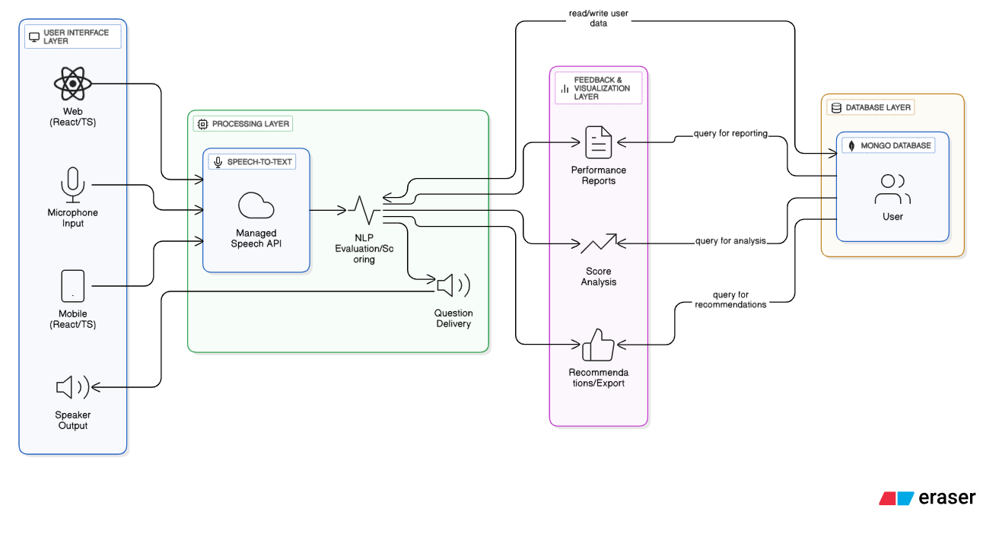

**Fig 4.1 Architectural Diagram**

**4.2 DATA DESIGN**

The data design for the AI Interview Assistant is focused on structuring the information to effectively support user authentication, real-time analysis, and historical performance tracking. The system primarily organizes its information around three core entities: Users, the Question Bank, and Session Records.

**User Entity (Authentication & Profile):** This entity stores the basic data required for security and personalized access. Crucial fields include the unique User_ID (Primary Key), Username, and a securely stored Password_Hash (using techniques like bcrypt). It also tracks non-sensitive data such as Email and Registration_Date. The use of hashing is mandatory to protect user credentials and ensure overall data security.

**Question Bank Entity (Content Management):** This houses all the intellectual content that drives the practice sessions. Key fields include the Question_ID (Primary Key), the Question_Text itself, a Category tag (e.g., "HR," "Technical," "Behavioral"), and the Model_Answer_Text. This model answer text is vital as it serves as the benchmark against which the user's spoken answer is compared to calculate the Relevance Score.

**Session Record Entity (Analysis & History):** This is the core transactional entity, recording the outcome of every practice interview. It uses Session_ID (Primary Key) and includes foreign keys linking it back to the User_ID and Question_ID. Its primary function is to store all the analysis results: the raw User_Transcript (from S2T), calculated metrics like Filler_Word_Count, and the final Relevance_Score, Clarity_Score, and Confidence_Score. It also holds the Feedback_Summary generated by the backend.

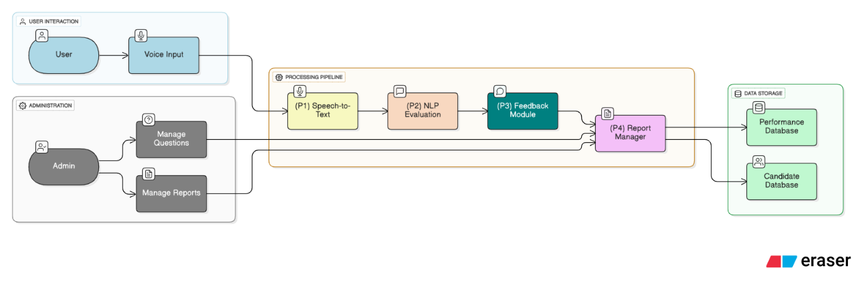

**Fig 4.2 Data Diagram**

**4.3 USER INTERFACE DESIGN**

The User Interface (UI) design for the AI Interview Assistant prioritizes usability, clarity, and focus for an optimal practice environment. The interface adheres to a clean, modern aesthetic using a neutral color palette to minimize eye strain. The core design principle is a conversational flow, guiding the user smoothly from logging in to reviewing performance reports. The layout is responsive, ensuring a consistent, high-quality experience across desktop, laptop, and mobile browsers, with a highly visible microphone control (F2 requirement). Navigation is simple, covering the Dashboard, Practice Session, and History/Reports.

The visual presentation of data is critical for actionable feedback. Instead of raw numbers, the UI utilizes visual aids like color-coded status indicators (green/yellow/red) and dial gauges to display objective scores for Relevance, Clarity, and Confidence (F3 requirement). The post-session report is structured logically, juxtaposing the System's Model Answer against the User's Transcribed Text. A dedicated panel details metrics like detected filler words and speaking rate, providing concrete data for improvement. All historical data is easily accessible, turning practice history into a valuable learning tool (F4 requirement).

**Key Screens of AI Interview Assistant:**

**1. Login/Registration Screen:**

* Purpose: To secure the application and authenticate the user (F1).
* Elements: Fields for Username/Email and Password, secure login button, and an option to register a new account.

**2. User Dashboard (Home):**

* Purpose: The main landing page for an overview of performance and navigation.
* Elements: A quick summary of the last session's scores, a prominent "Start New Session" button, and navigation links to History.

**3. Practice Session Screen:**

* Purpose: The core, real-time environment for the voice interview interaction.
* Elements: A highly visible Microphone Control (to start/stop recording), the current question displayed (via TTS output), and a timer tracking the answer length.

**4. Post-Session Report:**

* Purpose: To deliver detailed, data-driven feedback immediately after a session (F4).
* Elements: Visual Score Gauges for Confidence, Clarity, and Relevance. A text comparison showing the Model Answer versus the User's Transcribed Text, and a metrics panel listing filler words.

**5. Session History:**

* Purpose: To track long-term performance and progress (F4).
* Elements: A sortable and searchable table of all previous sessions, allowing the user to filter records and click to reload any detailed report.

**6. Question Management (Admin Screen):**

* Purpose: Interface for administrators to update and maintain the system's content (F5).
* Elements: Forms to add, edit, or delete questions, including fields for Question Text, Category, and the Model Answer. (Requires administrator credentials).

**4.4 ELEMENTS OF ANALYSIS MODEL**

The analysis model for the AI Interview Assistant translates the system's core functional goals into a defined, multi-step data processing sequence, ensuring every user interaction yields objective, actionable feedback. This model defines the necessary components to transform spoken input into numerical scores. The process begins when the user's spoken answer is captured and converted by the Speech-to-Text (S2T) engine into the User Transcript, which acts as the foundational Input Data Element. This transcript is then fed into the Analysis Process (NLP Engine), the core software component responsible for all computation. The engine leverages the Comparative Data Element (Model Answer Text)—the ideal response stored in the database—as the benchmark for accurate scoring.

The Analysis Process generates the final Output Metrics (Session Scores), consisting of the objective numerical values for Relevance (semantic match), Clarity (readability), and Confidence (filler word frequency). Once these scores are calculated, they are aggregated along with the User Transcript and a generated Feedback Summary into a secure Data Storage Element (Session Record). This crucial record is persistently archived in the Data Layer, fully satisfying the reporting requirement (F4) by allowing users to track their progress and review detailed historical performance data.

**4.4.1 USE CASES AND USE CASE DIAGRAM**

The Use Case Model identifies the functional boundaries of the AI Interview Assistant by defining all user interactions (Actors) with the system (Use Cases). The primary actor is the User (the job seeker), while the secondary actor is the Administrator.

**Use Cases (Functional Requirements)**

1. **Authentication and Profile Management (F1):**
   * **Login to System:** User provides credentials to gain secure access.
   * **Register Account:** User creates a new personalized profile.
   * **Manage Profile:** User updates personal information (e.g., email, password).
2. **Interview Session Management (F2, F3):**
   * **Start New Practice Session:** User initiates an interview session.
   * **Receive Question (TTS):** System delivers the question via Text-to-Speech (TTS). (Includes include$\gg$ Receive Question).
   * **Submit Spoken Answer:** User speaks their response into the microphone. (Includes include$\gg$ Transcribe Audio).
   * **Receive Real-time Analysis:** System immediately processes the answer and calculates the scores.
3. **Reporting and History (F4):**
   * **View Dashboard Summary:** User accesses the main screen to see a snapshot of recent performance.
   * **View Session History:** User retrieves a list of all past practice sessions.
   * **View Detailed Report:** User selects a session to view the score breakdown, transcript comparison, and feedback summary.
4. **Content Management (F5 – Administrator Only):**
   * **Manage Question Bank:** Administrator adds, modifies, or deletes questions and their corresponding Model Answers.

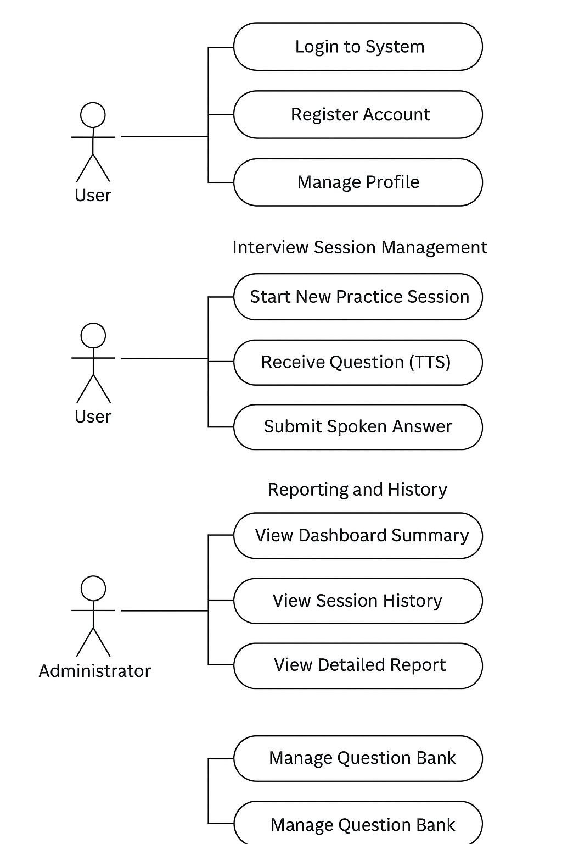

 **Fig 4.2 Use Case Diagram**



**Fig 4.3 USE CASE ADMIN**

**4.4.2 SEQUENCE DIAGRAM**

Sequence Diagram visually maps out the step-by-step communication that happens when a user conducts a practice interview session. It shows the exact order of messages between different parts of the system, which are represented as vertical lifelines.

This diagram focuses on the key use case: Interview Session Management (F2, F3), which covers asking a question and receiving an answer/feedback.

The interaction begins when the User tells the User Interface (UI) to start a session. The UI sends a request to the Session Controller (the brain of the operation), which gets a question from the Question Bank. The Controller sends the question text to the Text-to-Speech (TTS) Service to convert it into audio, which is then delivered back to the UI for the user to hear.

The user speaks their Spoken Answer (Submitting Answer). This audio is sent to the Speech Analysis Engine. This engine performs two key functions: it first Transcribes Audio (converts speech to text), and then nalyses the content, language, and pace. Finally, it sends the Real-time Score and Feedback back to the UI, completing the practice cycle for one question. This entire flow illustrates the exact timing and order of operations needed for the system to function correctly.

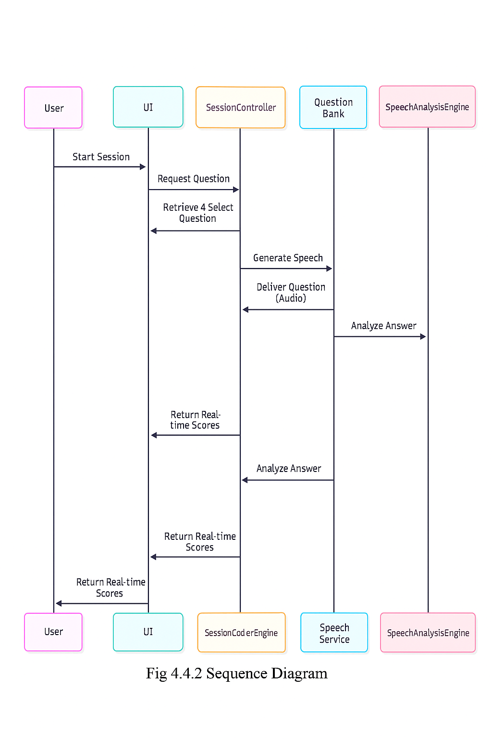

**Fig 4.4.2 SEQUENCE DIAGRAM**

**Key Steps in the Sequence:**

* **Start Session:** The User initiates the process.
* **Request Question**: The User Interface (UI) sends a request to the Session Controller.
* **Retrieve & Select Question:** The Session Controller queries the Question Bank for a question.
* **Generate Speech:** The Session Controller sends the question text to the Text-to-Speech (TTS) Service.
* **Deliver Question (Audio):** The TTS Service sends the audio stream back to the UI.
* **Analysis Answer**: After the user submits their spoken answer, the UI sends the audio to the Speech Analysis Engine**.**
* **Return Real-time Score:** The Speech Analysis Engine processes the audio (including transcription) and sends the performance scores back to the UI.

**4.4.3 ACTIVITY DIAGRAM**

The Activity Diagram shows the complete journey a user takes during a practice interview session, focusing on the actions and steps within the system. It starts when the user chooses to begin the session. At this point, the process immediately splits into two simultaneous actions, known as a Fork. The first action is where the system gets the next Interview Question and prepares the Audio version of it. The second action is the system setting up and starting the Recording so it’s ready to capture the user’s voice right away.

Once the system has both finished preparing the question and started the recording (a Join point), the user delivers their spoken answer. This answer is immediately sent to the system for analysis. The system first converts the spoken words to text (Transcription), and then it reviews the content and delivery (Answer Analysis). Finally, it creates the final Score and Feedback, which is delivered to the user. The user then faces a choice (Decision): they can either decide to move on to the Next Question to continue practicing or choose to End the Session.

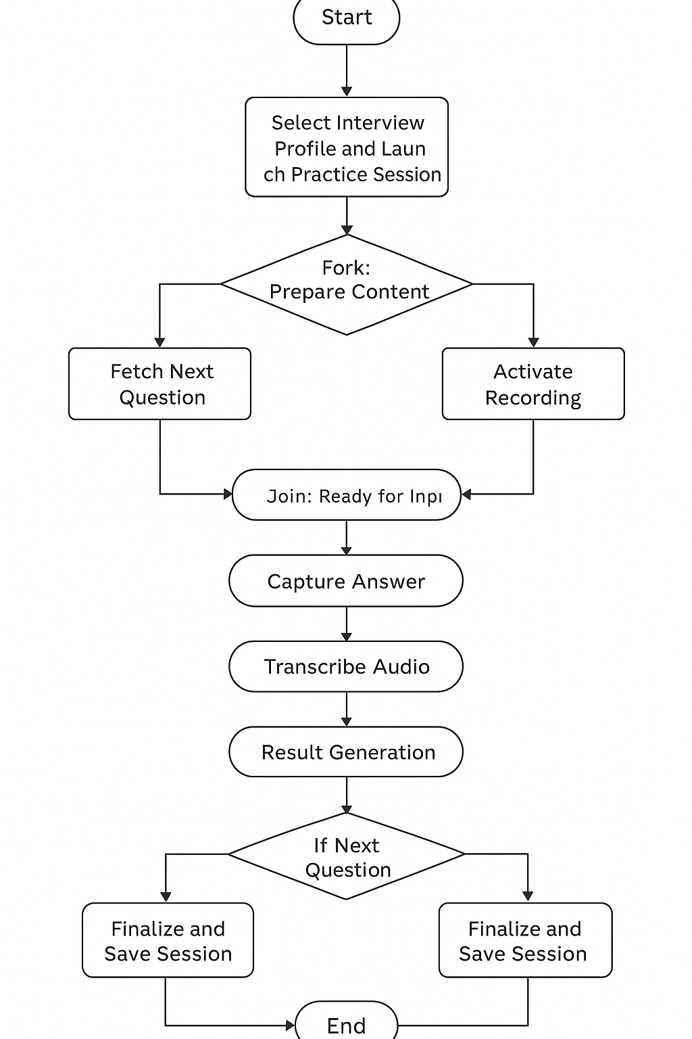

**Fig 4.4.3ACTIVITY DIAGRAM**

**4.4.4 CLASS DIAGRAM**

This diagram uses standard UML notation to represent the classes, their key attributes (data), and the associations (relationships) that define the system's static structure.

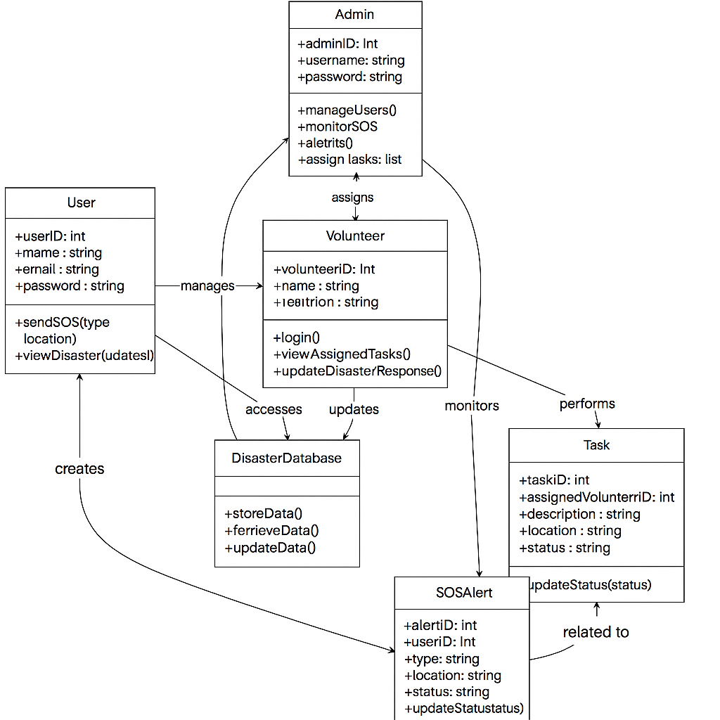

**Fig 4.4.4 CLASS DIAGRAM**

**4.4.5 E-R DIAGRAM**

The Entity–Relationship (ER) diagram of the **AI Interview Assistant** project illustrates the logical structure and interaction between various entities in the system. The design ensures efficient data flow between user profiles, interviews, responses, and system evaluations..

**Main Entities:**

* + **Users:** Authenticates individuals and stores profile details.
  + **Profiles:** Customizes interview preferences per user.
  + **Sessions:** Tracks practice interactions with timing and status.
  + **Questions**: Stores interview prompts and model answers.
  + **Reports:** Captures post-session scores, metrics, and feedback.

**Relationships**

* User → Interview_Session → One-to-Many: A single user can conduct multiple interview sessions.
* Interview_Session → Response → One-to-Many: Each session includes multiple responses correspond ding to questions.
* Question_Bank → Response → One-to-Many: Each question may be answered multiple times by different users.
* Response → Evaluation → One-to-One: Each response generates one evaluation record.
* Interview_Session → Report → One-to-One: Each completed session results in one final report.

**Design Rationale**

* **Scalability**: UUID-based PKs avoid sequential ID issues in distributed systems.
* **Query Efficiency**: FKs enable joins for dashboards (e.g., fetch user sessions with reports).
* **Data Integrity**: Timestamps track audit trails; scores as floats allow nuanced analysis.
* **Extensions**: Future additions could include a Responses entity for raw transcriptions, linking to Reports for deeper NLP storage.

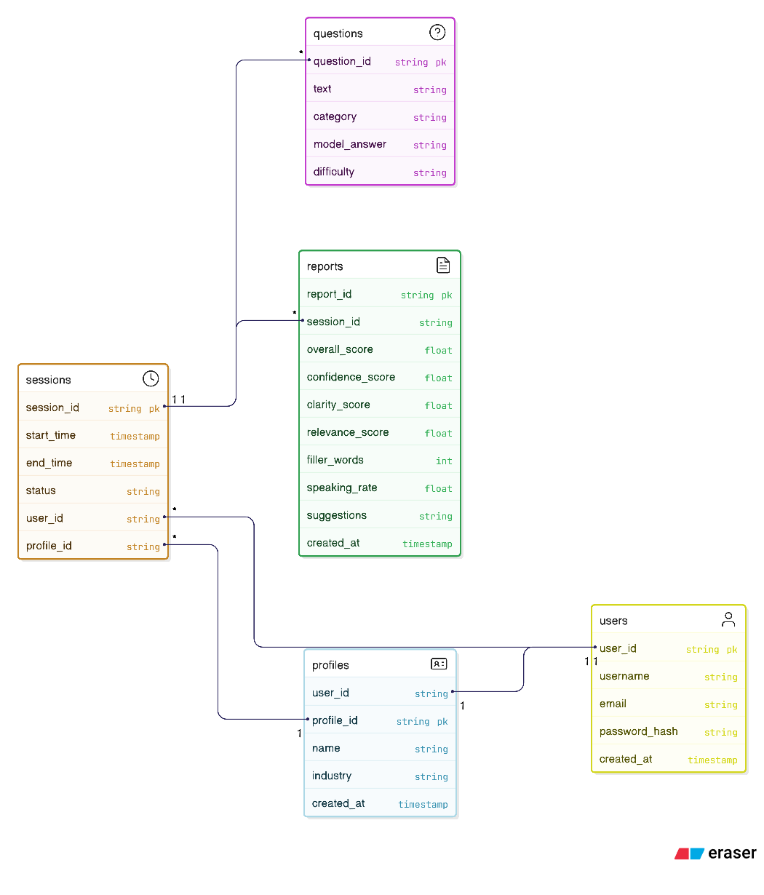

**Fig 4.4.5 E-R DIAGRAM**

**CHAPTER 5**

**IMPLEMENTATION**

The development process focused heavily on integrating various services, with the primary challenge being ensuring smooth API communication between them. Our system was designed with two initial code segments: one dedicated module for setting up and delivering interview questions in a natural, conversational style, and a second crucial component that utilized a specific speech-to-text library (like Google or Azure) to accurately capture and instantly transcribe the user's spoken audio into text data.

The core of the system is the analysis logic, which processes this transcribed text. We leveraged a robust NLP library (e.g., NLTK or spaCy) to break down the answer. To check the answer's relevance, we calculated the cosine similarity against a model response. Separately, the logic evaluated confidence and clarity by identifying and counting filler words (like "um" or "uh") and analyzing the complexity and structure of the user's sentences.

**Steps in Implementation**

1. **Set Up Question Module & API:**

* Configure the core component responsible for storing, retrieving, and naturally formatting interview questions. Establish the API endpoint to deliver questions to the user interface.

1. **Integrate Speech-to-Text (STT) Library**:

* Implement the chosen STT library (e.g., Google, Azure, or proprietary) to handle real-time capture and accurate transcription of the user's spoken audio into text data.

1. **Develop Natural Language Processing (NLP) Logic**:

* Build the core scoring engine using an NLP library (like spaCy or NLTK). This logic is responsible for breaking down the transcribed text.

1. **Implement Content Relevance Scoring:**

* Develop the function to calculate cosine similarity between the user's transcribed answer and a pre-defined model answer to determine the answer's relevance and depth.

1. **Create Clarity & Confidence Analysis:**

* Code separate functions to identify and count filler words (like "um," "uh") and analyze sentence structure/length to generate metrics for clarity and confidence.

1. **Design Feedback and Reporting Module:**

* Create the module that aggregates all scores (relevance, clarity, confidence) and generates the final, actionable feedback report displayed to the user.

1. **System Integration & Testing:**

* Conduct comprehensive testing across all modules—from question delivery and audio capture to final score generation—to ensure seamless flow and accurate data integration across the entire practice session.

**Outcome of Implementation**

* Successful System Integration: All core modules Question Posing, Audio Capture, NLP Analysis, and Feedback Generation were successfully linked, establishing a seamless, real-time workflow for the user's practice session.
* Accurate Real-Time Transcription: The integration of the Speech-to-Text library enabled the system to accurately capture the user's spoken answers and instantly transcribe them, serving as the necessary input for the scoring engine.
* Data-Driven Performance Metrics: The core NLP logic successfully generated objective metrics, including Content Relevance via Cosine Similarity and Communication Clarity by identifying and counting filler words and analyzing sentence structure.
* Actionable Feedback Reports: The system produced clear, comprehensive reports that went beyond a simple score, offering users specific, actionable suggestions based on their performance across all analyzed categories.
* Functionality Verification: Through unit and system-level testing, the implementation was verified to be robust, ensuring high accuracy in scoring and reliable data handling across the entire application lifecycle.
* Foundation for Scalability: The modular code structure and choice of libraries established a solid foundation, allowing for easy expansion of features, question sets, and deployment across various platforms.

**TYPES OF MODULES WITH EXPLAINATION**

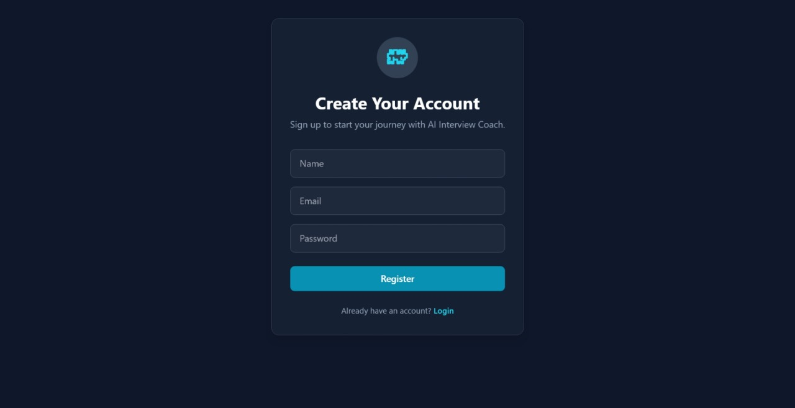

**Fig 5 (a) USER REGISTER**

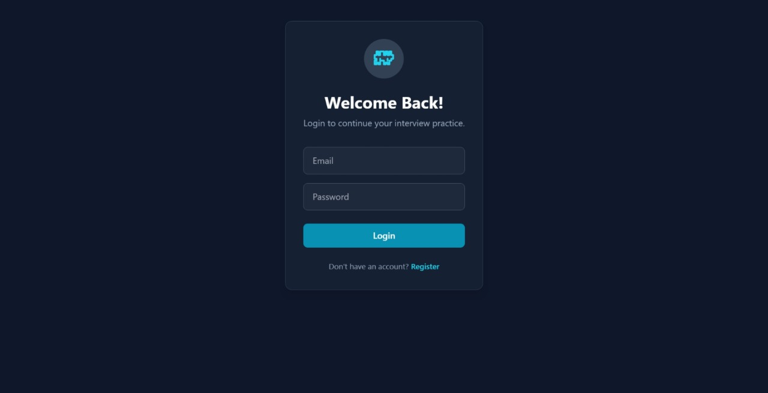

**Fig 5 (b) LOGIN PAGE**

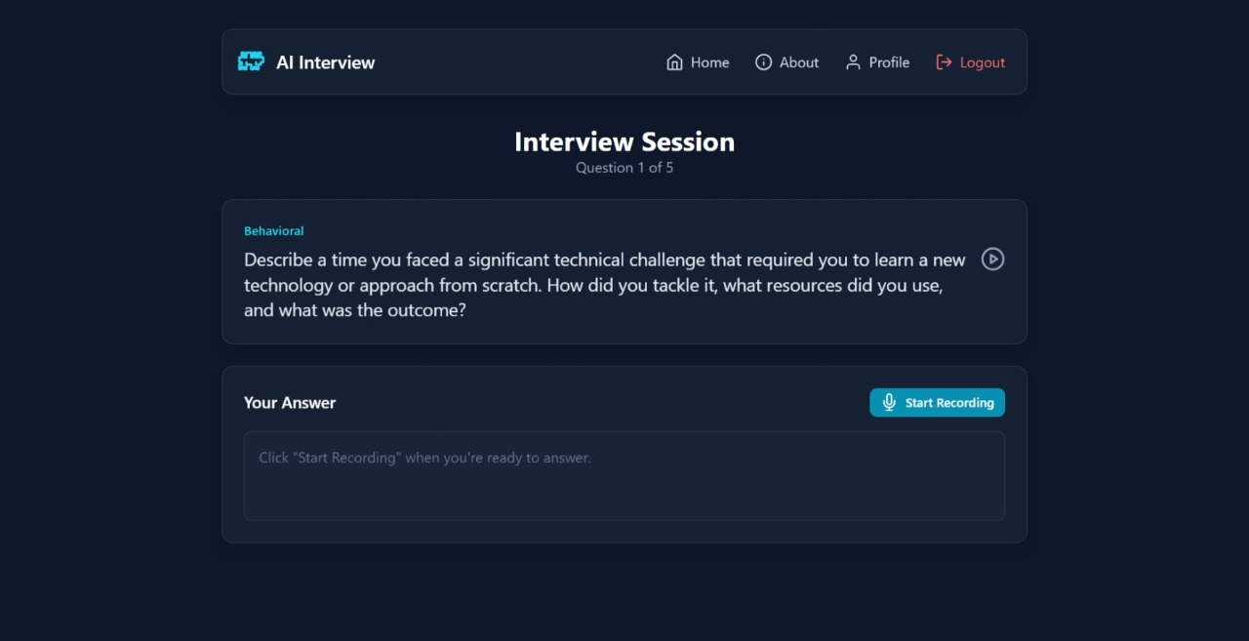

**Fig 5 (c) HOME PAGE**

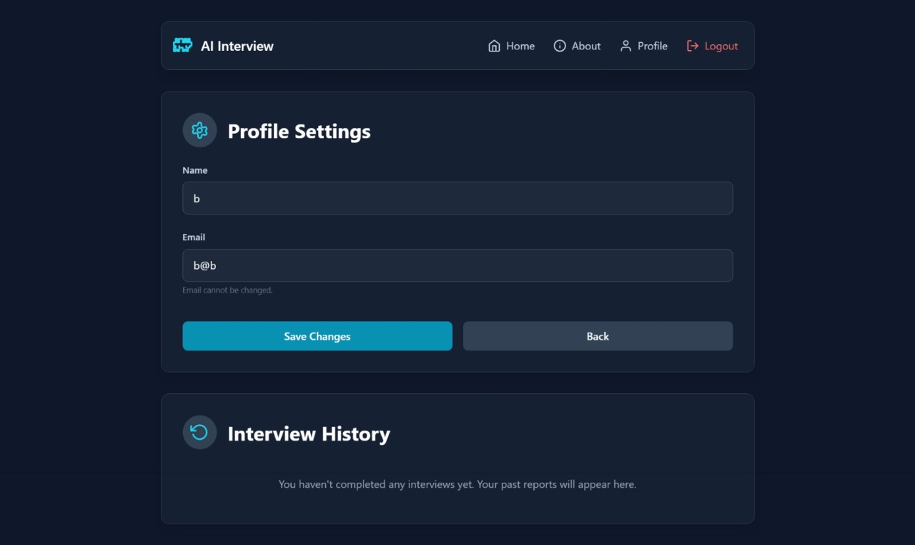

**Fig 5 (d) PROFILE PAGE**



**Fig 5 (e) PROFILE PAGE**

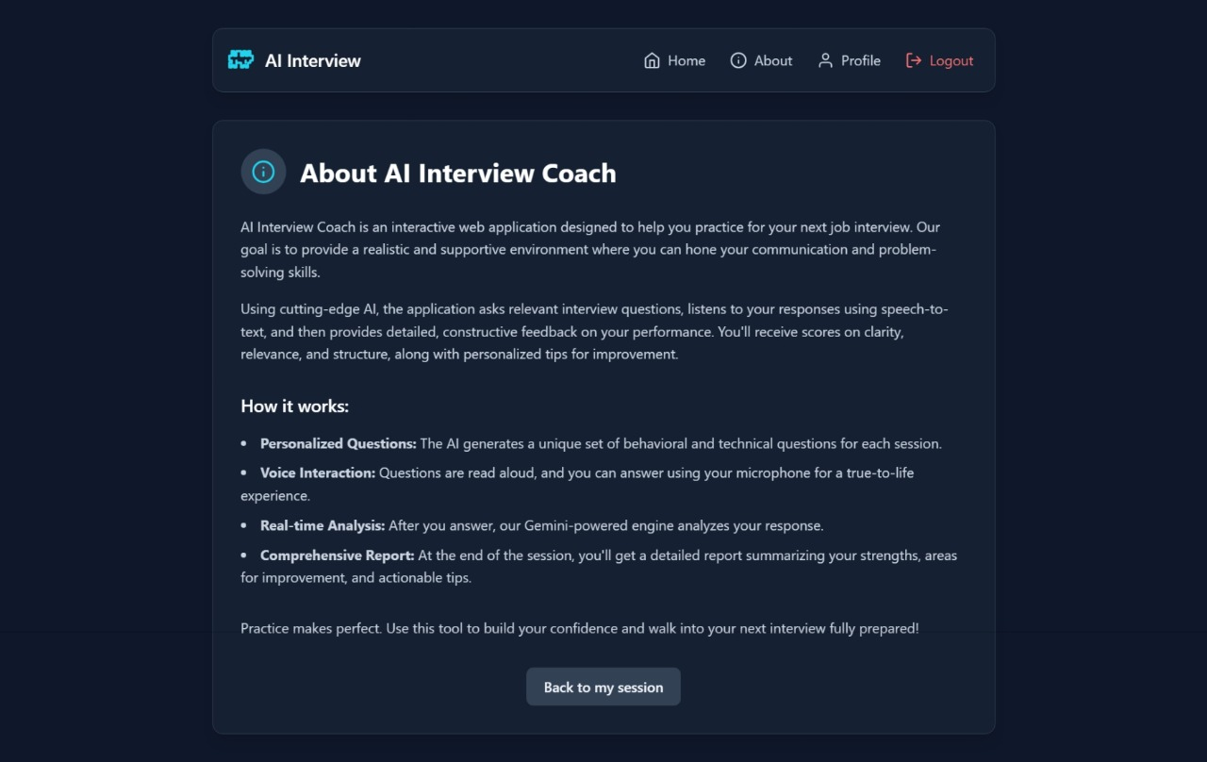

**Fig 5 (f) ABOUT PAGE**

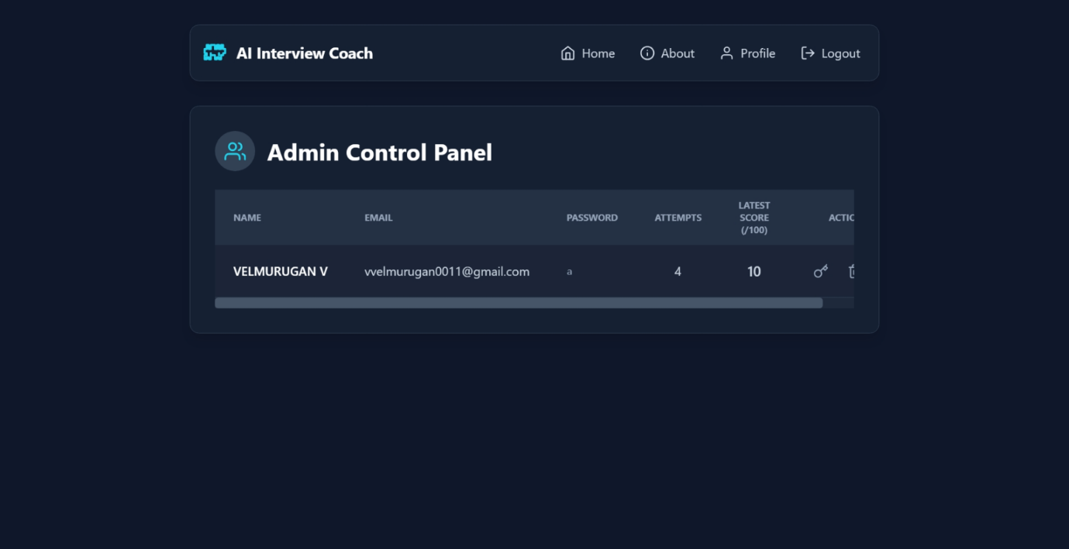

**Fig 5 (g) ADMIN**

**CHAPTER 6**

**TESTING**

Testing is an essential phase of the software development life cycle. It ensures the developed system performs correctly, meets user expectations, and is free from defects. For the AI Interview Simulation System, a systematic testing process was followed that included unit testing, integration testing, validation testing, and performance testing. The overall objective of testing was to guarantee the application delivers accurate speech transcription, precise NLP scoring (relevance and clarity), secure user session management, and a smooth, real-time interview experience.

## **6.1 TEST PLAN**

A detailed test plan was created to define the scope and strategy for the AI Interview Simulation System. The main objective was to verify both functional (what the system does) and non-functional (how well it does it) requirements.

Functional testing focused on ensuring accurate audio transcription, correct question delivery, precise NLP scoring for relevance and filler words, and proper feedback report generation. Non-functional testing verified performance (speed), security (data safety), and usability during the practice session.

We used Py test for the core scoring logic, Postman to validate data flow between backend services (like the transcription API and the scoring engine), and UI checks for real-time interaction. Database checks confirmed all interview history was correctly stored. The expected outcome was to guarantee that all modules worked together perfectly, providing accurate, reliable, and secure results.

**6.2 UNIT TESTING**

Unit testing was conducted on each individual component to ensure that every part of the system worked correctly in isolation.

* **Frontend (UI/Display):** Tested the user interface for correct rendering of the interview screen, accurate display of the question, and the reliable presentation of the final score and feedback charts.
* **Audio/Question Module:** Verified that the Text-to-Speech function correctly delivered the audio question and that the Speech-to-Text (STT) component accurately transcribed pre-recorded audio samples into text.
* **Scoring Backend (Python Logic):** Verified the core functionality of the Cosine Similarity calculation to ensure accurate content relevance scoring. Ensured the filler word counter and sentence structure analysis accurately processed sample text inputs.
* **Database (SQLite):** Validated operations like secure user session storage, data insertion of interview records, and reliable retrieval of past interview scores and detailed feedback.
* Unit testing confirmed that each building block of the AI Interview Simulation System performed accurately and consistently before progressing to system integration.

**6.3 INTEGRATION TESTING:**

Integration testing ensured that all modules interacted correctly with one another.

* The primary focus was on the communication between the user interface, the audio processing backend, and the SQLite database.
* Verified that the question from the delivery module was successfully passed to the user interface and the corresponding Speech-to-Text API was activated.
* Ensured that the user's recorded audio was accurately captured, transcribed, and immediately transferred to the NLP scoring engine for analysis.
* Checked that the generated analysis results, including the relevance score and filler word count, were correctly stored in the database and accurately displayed in the final feedback report on the frontend.
* Confirmed smooth interaction between the question delivery, audio processing, analysis logic, and database storage layers without any data loss or errors during the real-time session.

Integration testing validated the overall workflow from question posing to feedback display, confirming that the system’s components worked seamlessly together as a complete AI interview simulator.

**6.4 VALIDATION TESTING:**

Validation testing was performed to ensure the AI Interview Simulation System met every requirement defined in the initial plan.

* **Content Validation**: Verified that the NLP scoring worked correctly for a wide range of answers—checking both technically accurate responses and incomplete or poorly structured responses.
* **Audio/Real-Time Validation**: Checked functionality across different microphone qualities and background noise levels to ensure transcription accuracy remained high and consistent.
* **User Acceptance Testing (UAT)**: Conducted with sample users to confirm that the system was easy to use, that the **AI voice interaction** felt natural, and that the **feedback reports** were clear and helpful for real-world improvement.

Validation testing confirmed that the application was reliable, provided accurate scoring, and was easy to use, successfully fulfilling both its functional goals and quality requirements.

**CHAPTER 7**

**CONCLUSION & FUTURE ENHANCEMENTS**

**CONCLUSION**

The Interview Voice Assistant project successfully delivered an innovative, voice-driven platform for automated interview preparation. The system's success was rooted in the careful integration of core technologies: Speech-to-Text (STT) accurately transcribed user responses, Natural Language Processing (NLP) analyzed the resulting text for relevance and clarity, and Text-to-Speech (TTS) ensured a natural, realistic delivery of interview questions. This combination provides job seekers with an objective, data-driven assessment crucial for improving performance.

Rigorous unit and integration testing confirmed the system's reliability, guaranteeing accurate scoring and a seamless, real-time user experience. The resulting platform offers a scalable self-assessment tool, utilizing advanced machine learning techniques to provide feedback on specific metrics like filler word count and content relevance. Ultimately, the project validates the use of conversational AI in educational tools, enabling users to confidently enhance both their communication style and answer content for high-stakes professional settings.

**FUTURE ENHANCEMENTS:**

Future development could include:

1. **Emotion :** Integrating tools to detect emotional tone (stress, enthusiasm) from the voice for deeper confidence analysis.
2. **Video Integration:** Adding a camera option to analyze body language and eye contact during the simulation.
3. **Expanded Question Library:** Implementing a paid model for access to specialized question sets (e.g., Data Science, Cybersecurity).

Future development of the platform will focus on enhancing the depth and realism of the interview analysis. One major enhancement involves adding Emotion Detection by integrating specialized tools to analyse the user's voice tone.

This will allow the system to identify signs of stress, nervousness, or enthusiasm, providing a much deeper, data-driven assessment of the user’s confidence and composure during the high-stakes simulation. Additionally, integrating a Video option will allow the system to analyze non-verbal cues, such as body language and eye contact, offering a complete, holistic view of the user’s presentation skills.

To broaden the system's commercial reach and educational value, the Question Library will be significantly expanded. This involves implementing a tiered access model where users can unlock specialized, advanced question sets relevant to specific high-demand fields, such as Data Science, Cybersecurity, or specialized leadership roles. This feature transforms the tool from a general practice utility into a highly specialized, career-specific preparation resource, significantly increasing its value and market appeal.

# **BIBLIOGRAPHY**

1. Ian Sommerville, Software Engineering, 10th Edition, Pearson Education, 2016. *(Relevant for overall system development life cycle.)*
2. Thomas Connolly and Carolyn Begg, Database Systems: A Practical Approach to Design, Implementation and Management, 6th Edition, Pearson Education, 2015. *(Relevant for user and session data storage.)*
3. Aurélien Géron, Hands-On Machine Learning with Scikit-Learn, Keras, and TensorFlow, O’Reilly Media, 2nd Edition, 2019. *(Relevant for building the core NLP scoring models.)*
4. Wes McKinney, Python for Data Analysis: Data Wrangling with Pandas, NumPy, and IPython, O’Reilly Media, 2nd Edition, 2018. *(Relevant for data handling and analysis within the scoring logic.)*
5. Daniel Jurafsky and James H. Martin, Speech and Language Processing, 3rd Edition, Pearson Education, 2023. *(Highly relevant for foundational concepts in Speech-to-Text and Text-to-Speech.)*
6. Raj Kamal, Internet and Web Technology, Tata McGraw Hill Education, 2019. *(Relevant for API integration and web deployment.)*
7. Steven Bird, Ewan Klein, and Edward Loper, Natural Language Processing with Python – Analyzing Text with the Natural Language Toolkit, O’Reilly Media, 2009. *(Highly relevant for the NLP analysis and scoring techniques.)*
8. Streamlit Documentation – <https://docs.streamlit.io/> *(Relevant for the UI/Frontend framework used in the implementation.)*
9. Scikit-learn Documentation – <https://scikit-learn.org/> *(Relevant for implementation details of similarity and vectorization algorithms.)*
10. Google Cloud Speech-to-Text API Documentation – [Insert Link to relevant API Docs] *(Relevant for the core Speech-to-Text implementation.)*

**APPENDIX A**

**Table Name: User_Details**

|  |  |  |
| --- | --- | --- |
| **Field Name** | **Data Type** | **Description** |
| user_id | ObjectId (Primary Key) | Unique identifier for each user |
| full_name | TEXT | Full name of the user |
| email | TEXT | Registered email ID used for login |
| password | TEXT | Encrypted password (hashed using SHA-256 or bcrypt) |
| role | TEXT | User role (e.g., candidate, admin) |
| created_at | DATETIME | Account creation timestamp |

**Table [1]**

**Table Name: Interview_Questions**

|  |  |  |
| --- | --- | --- |
| **Field Name** | **Data Type** | **Description** |
| question_id | ObjectId (Primary Key) | Unique identifier for each question |
| category | TEXT | Category of question (Technical, Behavioral, HR, etc.) |
| difficulty | TEXT | Difficulty level (Easy, Medium, Hard) |
| question_text | TEXT | The actual question displayed to the user |
| model_answer | TEXT | Ideal or sample answer for comparison |
| created_at | DATETIME | Timestamp when the question was added |

**Table [2]**

**Table Name: Interview_Sessions**

|  |  |  |
| --- | --- | --- |
| **Field Name** | **Data Type** | **Description** |
| session_id | ObjectId (Primary Key) | Unique session identifier |
| user_id | ObjectId (Foreign Key) | Linked user who took the interview |
| start_time | DATETIME | Session start time |
| end_time | DATETIME | Session end time |
| status | TEXT | Status of session (Active, Completed, Terminated) |

**Table [3]**

**Table Name: Responses**

|  |  |  |
| --- | --- | --- |
| **Field Name** | **Data Type** | **Description** |
| response_id | ObjectId (Primary Key) | Unique identifier for each response |
| session_id | ObjectId (Foreign Key) | Linked session identifier |
| question_id | ObjectId (Foreign Key) | Linked question identifier |
| audio_file | TEXT | Path or link to stored audio response |
| transcribed_text | TEXT | Converted text from the user’s speech |
| timestamp | DATETIME | Time when the response was recorded |

**Table [4]**

**Table Name: Admin_Controls**

|  |  |  |
| --- | --- | --- |
| **Field Name** | **Data Type** | **Description** |
| admin_id | ObjectId (Primary Key) | Unique identifier for admin |
| username | TEXT | Admin username |
| email | TEXT | Admin contact email |
| permissions | TEXT | Defines access privileges (add, edit, delete questions) |
| last_login | DATETIME | Last login timestamp |

**Table [5]**

**APPENDIX B**

**SCREENSHOTS**



**Fig. B [1] : USER REGISTER**



**Fig B [2] : LOGIN PAGE**



**Fig B [3] : HOME PAGE**



**Fig B [4] : PROFILE PAGE**



**Fig B [5] PROFILE PAGE**



**Fig B [6] : ABOUT PAGE**



**Fig B [7] : ADMIN**

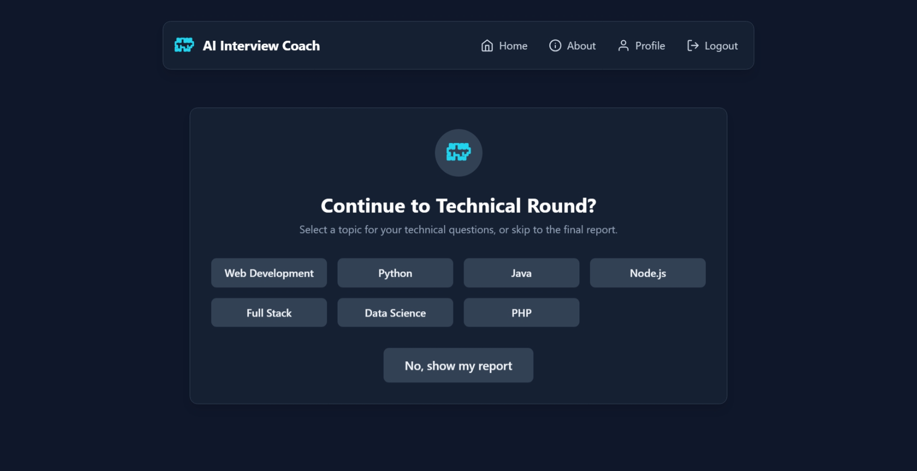 **Fig B [8] : TECHNICAL QUESTIONS**

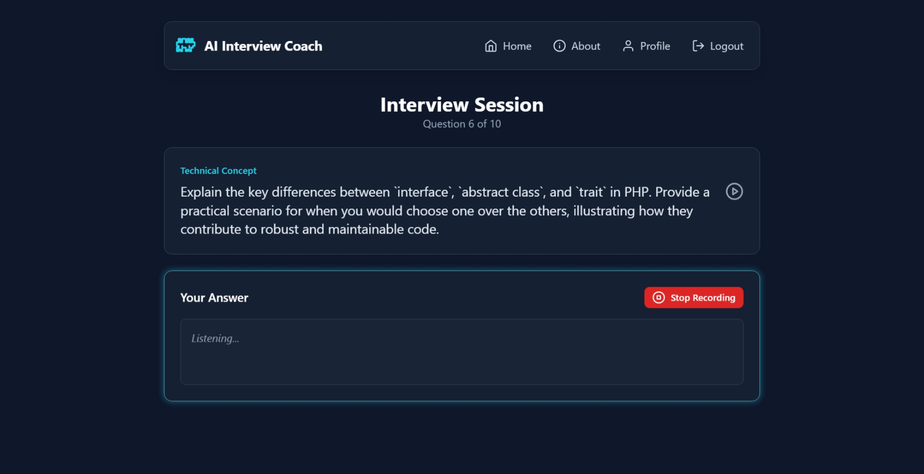

**Fig B [9] : TECHNICAL QUESTIONS**

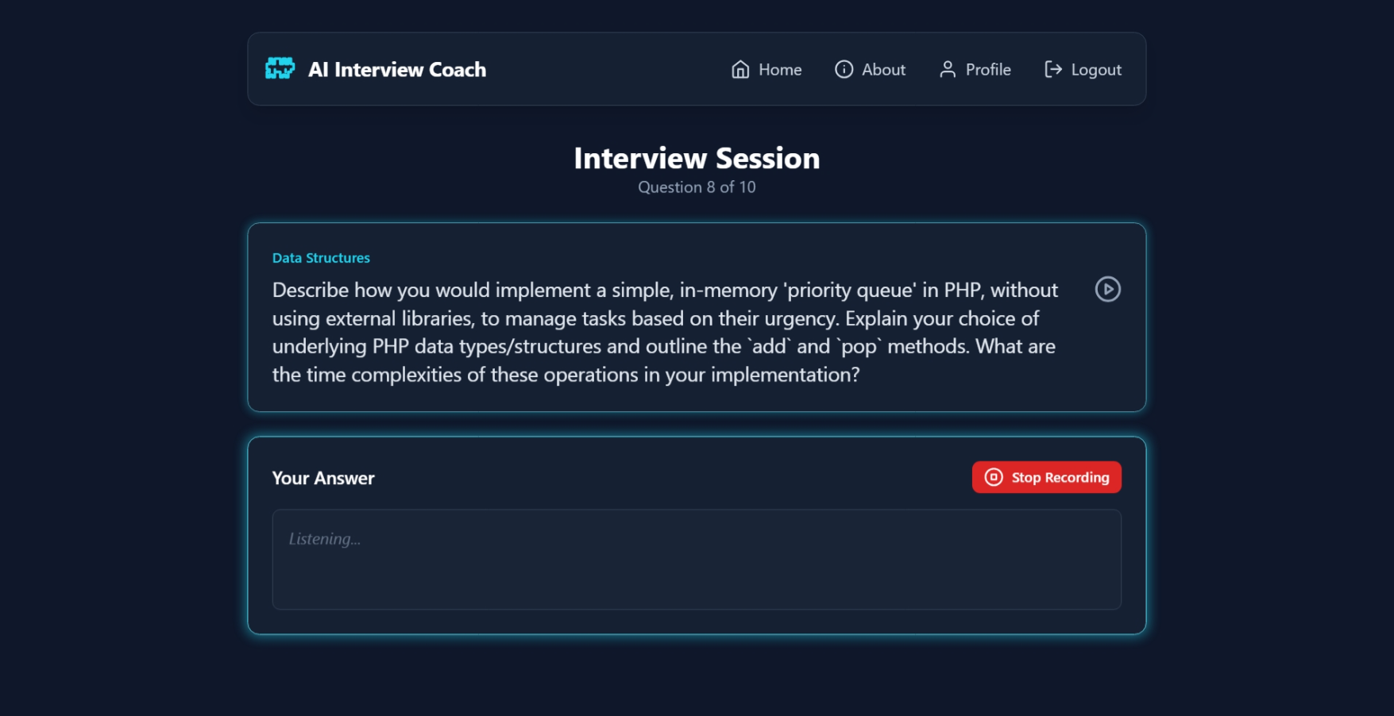

**Fig B [10] : TECHNICAL QUESTIONS**

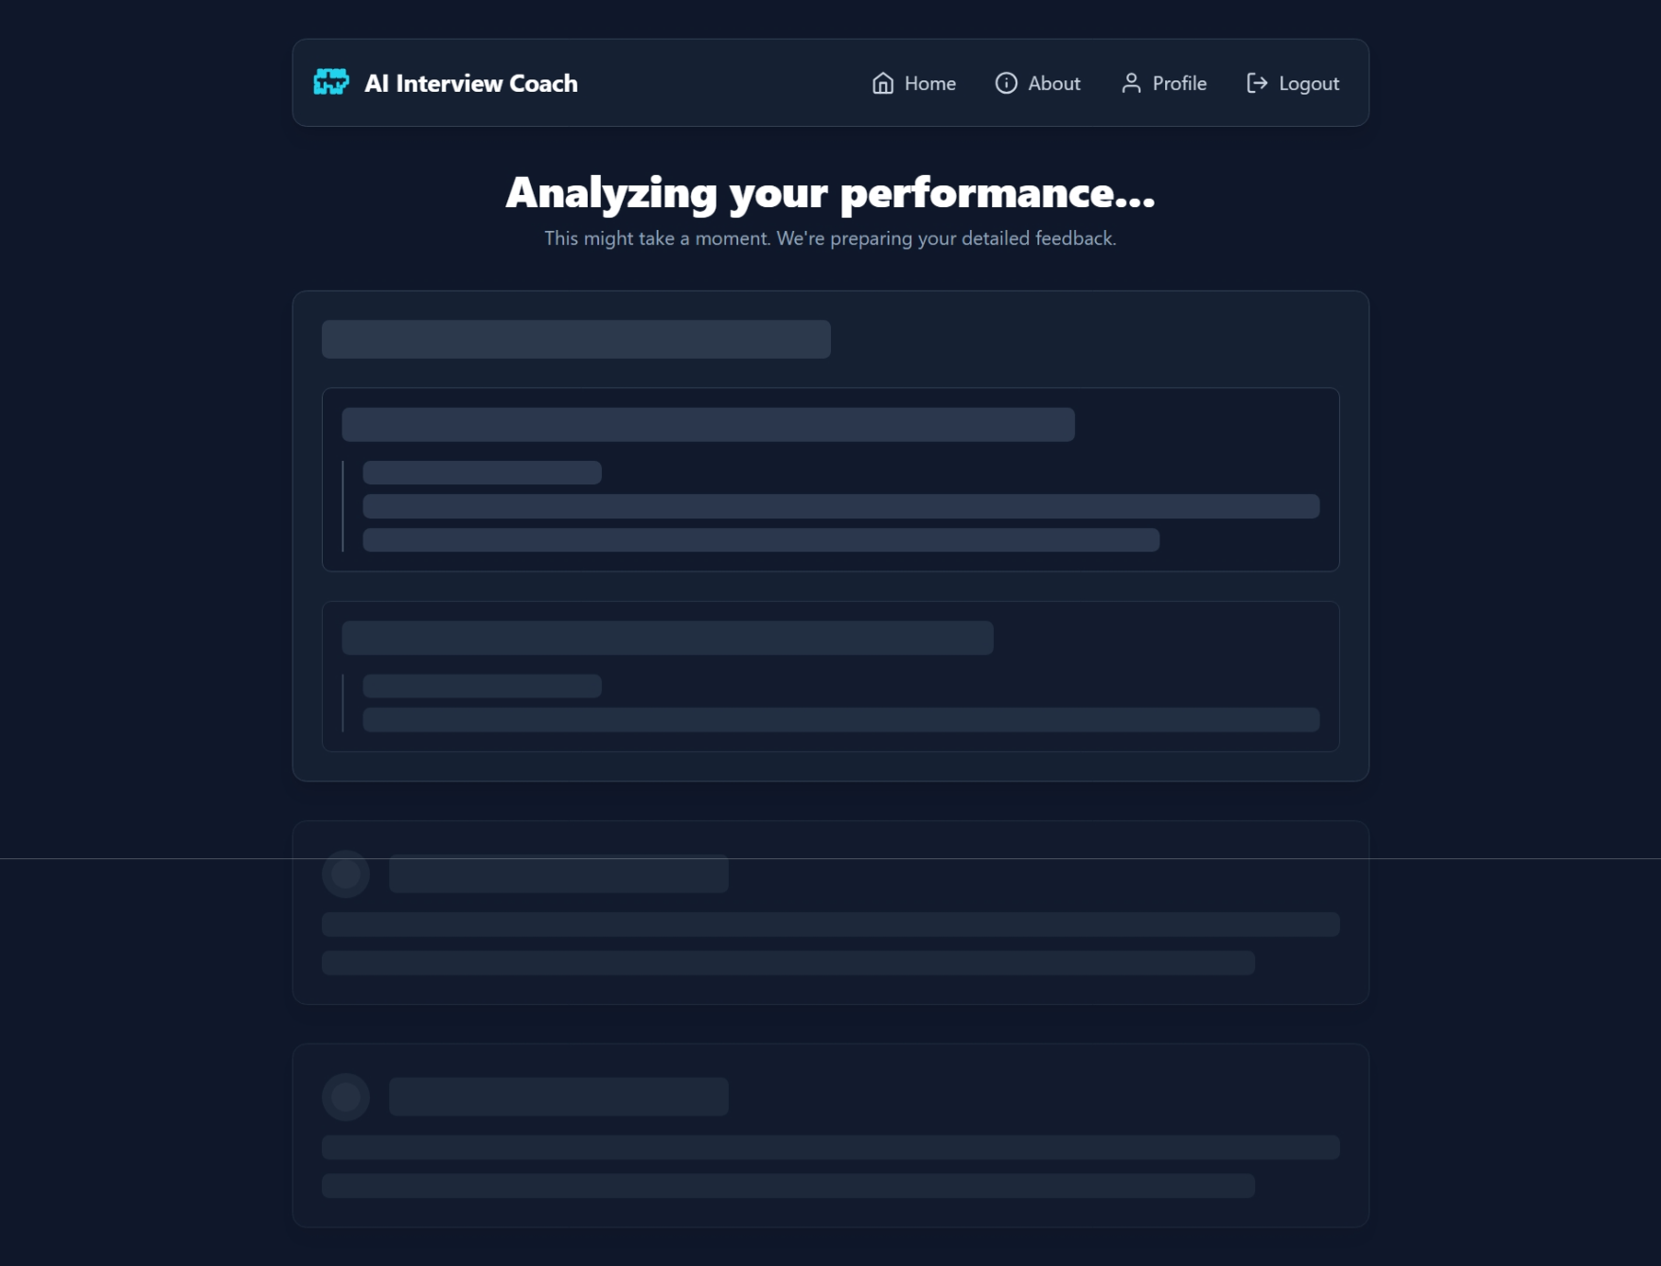

**Fig B [11] : PERFORMANCE**

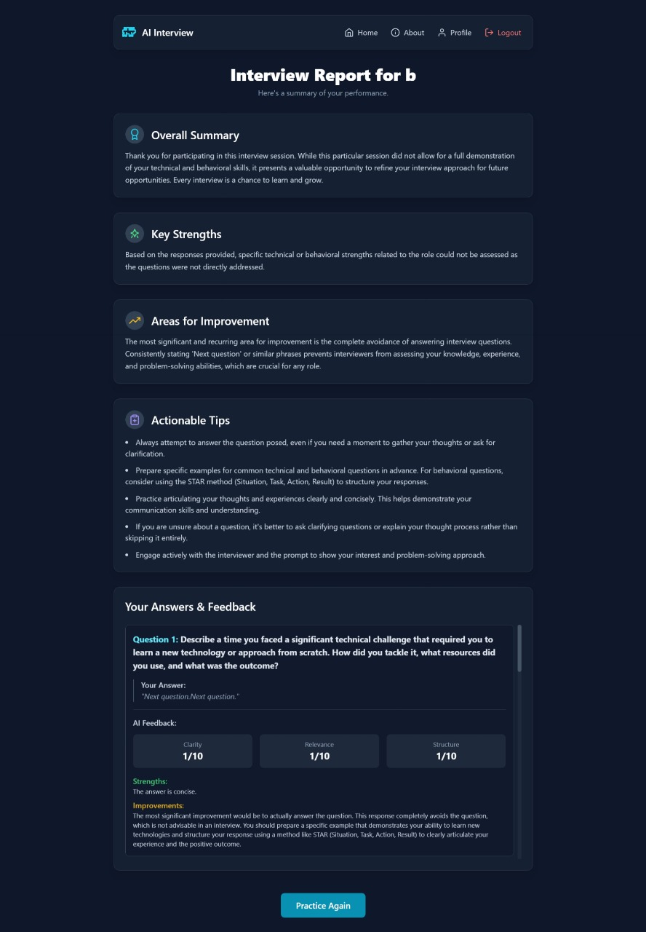

**Fig B [12] : REPORT**

**APPENDIX C**

**SAMPLE CODING**

import React, { useState, useEffect } from 'react';

import { StoredUser, InterviewRecord } from '../types';

import { getUsers, loadInterviewHistory, updateUserPassword, deleteUserByEmail } from '../backend/api';

import Card from './ui/Card';

import Button from './ui/Button';

import { UsersIcon, TrashIcon, KeyIcon } from './ui/icons';

import Spinner from './ui/Spinner';

const calculateScore = (record: InterviewRecord): number => {

    if (!record) return 0;

    const questionScores = record.interviewData

        .map(data => data.feedback?.scores)

        .filter((scores): scores is Exclude<typeof scores, null> => scores != null)

        .map(scores => (scores.clarity + scores.relevance + scores.structure) / 3);

    const avgQuestionScore = questionScores.length > 0

        ? questionScores.reduce((sum, score) => sum + score, 0) / questionScores.length

        : 0;

    let codingScore = 0;

    let hasCodingChallenge = false;

    if (record.finalReport.codingChallengeFeedback) {

        const feedback = record.finalReport.codingChallengeFeedback;

        codingScore = (feedback.correctness + feedback.efficiency + feedback.style) / 3;

        hasCodingChallenge = true;

    }

    let finalScoreOutOf10 = 0;

    if (hasCodingChallenge && questionScores.length > 0) {

        // Weighting: 60% questions, 40% coding

        finalScoreOutOf10 = (avgQuestionScore * 0.6) + (codingScore * 0.4);

    } else if (questionScores.length > 0) {

        finalScoreOutOf10 = avgQuestionScore;

    } else if (hasCodingChallenge) {

        finalScoreOutOf10 = codingScore;

    }

    return Math.round(finalScoreOutOf10 * 10);

};

const AdminPanel: React.FC = () => {

    const [users, setUsers] = useState<StoredUser[]>([]);

    const [isLoading, setIsLoading] = useState(true);

    const [userHistories, setUserHistories] = useState<Record<string, InterviewRecord[]>>({});

    const [showPasswordModal, setShowPasswordModal] = useState(false);

    const [showDeleteConfirm, setShowDeleteConfirm] = useState(false);

    const [selectedUser, setSelectedUser] = useState<StoredUser | null>(null);

    const [newPassword, setNewPassword] = useState('');

    const [feedbackMessage, setFeedbackMessage] = useState<string | null>(null);

    useEffect(() => {

        const fetchData = async () => {

            setIsLoading(true);

            const allUsers = await getUsers();

            const regularUsers = allUsers.filter(u => u.email !== 'admin@admin.com');

            setUsers(regularUsers);

            const histories: Record<string, InterviewRecord[]> = {};

            for (const user of regularUsers) {

                histories[user.email] = await loadInterviewHistory(user);

            }

            setUserHistories(histories);

            setIsLoading(false);

        };

        fetchData();

    }, []);

    const showFeedback = (message: string) => {

        setFeedbackMessage(message);

        setTimeout(() => setFeedbackMessage(null), 3000);

    };

    const closeModals = () => {

        setShowPasswordModal(false);

        setShowDeleteConfirm(false);

        setSelectedUser(null);

        setNewPassword('');

    };

    const handleOpenPasswordModal = (user: StoredUser) => {

        setSelectedUser(user);

        setNewPassword('');

        setShowPasswordModal(true);

    };

    const handleOpenDeleteConfirm = (user: StoredUser) => {

        setSelectedUser(user);

        setShowDeleteConfirm(true);

    };

    const handleDeleteUser = async () => {

        if (selectedUser) {

            await deleteUserByEmail(selectedUser.email);

            setUsers(users.filter(u => u.email !== selectedUser.email));

            showFeedback(`User ${selectedUser.name} deleted successfully.`);

        }

        closeModals();

    };

    const handleChangePassword = async () => {

        if (selectedUser && newPassword.trim()) {

            await updateUserPassword(selectedUser.email, newPassword.trim());

            setUsers(users.map(u => u.email === selectedUser.email ? { ...u, password: newPassword.trim() } : u));

            showFeedback(`Password for ${selectedUser.name} updated successfully.`);

        }

        closeModals();

    };

    return (

        <div className="animate-fade-in space-y-8">

            <Card>

                <div className="p-6 md:p-8">

                    <div className="flex items-center mb-6">

                        <div className="p-3 bg-slate-700 rounded-full mr-4">

                            <UsersIcon className="w-7 h-7 text-cyan-400" />

                        </div>

                        <h1 className="text-2xl sm:text-3xl font-bold text-white">Admin Control Panel</h1>

                    </div>

                    {isLoading ? (

                         <div className="flex justify-center py-12">

                            <Spinner />

                        </div>

                    ) : (

                        <div className="overflow-x-auto">

                            <table className="w-full text-left text-slate-300">

                                <thead className="bg-slate-700/50 text-xs text-slate-400 uppercase">

                                    <tr>

                                        <th scope="col" className="px-6 py-3">Name</th>

                                        <th scope="col" className="px-6 py-3">Email</th>

                                        <th scope="col" className="px-6 py-3">Password</th>

                                        <th scope="col" className="px-6 py-3 text-center">Attempts</th>

                                        <th scope="col" className="px-6 py-3 text-center">Latest Score (/100)</th>

                                        <th scope="col" className="px-6 py-3 text-right">Actions</th>

                                    </tr>

                                </thead>

                                <tbody>

                                    {users.map(user => {

                                        const history = userHistories[user.email] || [];

                                        const latestRecord = history[0];

                                        const score = latestRecord ? calculateScore(latestRecord) : 'N/A';

                                        return (

                                            <tr key={user.email} className="bg-slate-800/60 border-b border-slate-700 hover:bg-slate-800 transition-colors">

                                                <td className="px-6 py-4 font-medium text-white whitespace-nowrap">{user.name}</td>

                                                <td className="px-6 py-4">{user.email}</td>

                                                <td className="px-6 py-4 font-mono text-sm text-slate-400">{user.password}</td>

                                                <td className="px-6 py-4 text-center">{history.length}</td>

                                                <td className="px-6 py-4 text-center font-semibold text-lg">{score}</td>

                                                <td className="px-6 py-4">

                                                    <div className="flex gap-2 justify-end">

                                                        <button onClick={() => handleOpenPasswordModal(user)} className="p-2 text-slate-400 hover:text-cyan-400 rounded-md transition-colors" aria-label="Change Password">

                                                            <KeyIcon className="w-5 h-5" />

                                                        </button>

                                                        <button onClick={() => handleOpenDeleteConfirm(user)} className="p-2 text-slate-400 hover:text-red-400 rounded-md transition-colors" aria-label="Delete User">

                                                            <TrashIcon className="w-5 h-5" />

                                                        </button>

                                                    </div>

                                                </td>

                                            </tr>

                                        );

                                    })}

                                </tbody>

                            </table>

                            {users.length === 0 && (

                                <p className="text-center py-12 text-slate-400">No user data found.</p>

                            )}

                        </div>

                    )}

                </div>

            </Card>

            {showPasswordModal && selectedUser && (

                <div className="fixed inset-0 bg-black bg-opacity-70 flex items-center justify-center z-50 animate-fade-in">

                    <Card className="w-full max-w-md">

                        <div className="p-6">

                            <h2 className="text-xl font-bold mb-4 text-white">Change Password for {selectedUser.name}</h2>

                            <input

                                type="text"

                                value={newPassword}

                                onChange={(e) => setNewPassword(e.target.value)}

                                placeholder="Enter new password"

                                className="w-full px-4 py-3 bg-slate-800 border border-slate-600 rounded-lg focus:outline-none focus:ring-2 focus:ring-cyan-500 transition duration-200 text-white"

                                aria-label="New Password"

                            />

                            <div className="flex gap-4 mt-6">

                                <Button onClick={handleChangePassword} className="flex-1" disabled={!newPassword.trim()}>

                                    Save Password

                                </Button>

                                <Button onClick={closeModals} variant="secondary" className="flex-1">

                                    Cancel

                                </Button>

                            </div>

                        </div>

                    </Card>

                </div>

            )}

            {showDeleteConfirm && selectedUser && (

                <div className="fixed inset-0 bg-black bg-opacity-70 flex items-center justify-center z-50 animate-fade-in">

                    <Card className="w-full max-w-md">

                        <div className="p-6 text-center">

                            <h2 className="text-xl font-bold mb-2 text-white">Confirm Deletion</h2>

                            <p className="text-slate-400 mb-6">

                                Are you sure you want to delete the user <span className="font-semibold text-white">{selectedUser.name}</span>? This action cannot be undone.

                            </p>

                            <div className="flex gap-4">

                                <Button onClick={handleDeleteUser} variant="danger" className="flex-1">

                                    Yes, Delete User

                                </Button>

                                <Button onClick={closeModals} variant="secondary" className="flex-1">

                                    Cancel

                                </Button>

                            </div>

                        </div>

                    </Card>

                </div>

            )}

            {feedbackMessage && (

                <div className="fixed bottom-8 left-1/2 -translate-x-1/2 bg-green-600 text-white px-6 py-3 rounded-lg shadow-lg z-50 animate-fade-in">

                    {feedbackMessage}

                </div>

            )}

        </div>

    );

};

export default AdminPanel;

import speech_recognition as sr

import google.generativeai as genai

from openai import OpenAI

from faster_whisper import WhisperModel

import pyaudio

import os

import io

wake_word = "gemini"

listen_for_wake_word = True

whisper_size = "base"

OPENAI_KEY = "skhbjnorvno******ojnr"

GEMINI_KEY = "fwbeibowfn####***nevnoe"

genai.configure(api_key=GEMINI_KEY)

openai_client = OpenAI(api_key=OPENAI_KEY)

num_cores = os.cpu_count()

whisper_model = WhisperModel(

    whisper_size,

    device="cpu",

    compute_type="int8",

    cpu_threads=num_cores,

    num_workers=num_cores,

)

generation_config = {

    "temperature": 0.7,

    "top_p": 1,

    "top_k": 1,

    "max_output_tokens": 2048,

}

safety_settings = {

    genai.types.HarmCategory.HARM_CATEGORY_HATE_SPEECH: genai.types.HarmBlockThreshold.BLOCK_LOW_AND_ABOVE,

    genai.types.HarmCategory.HARM_CATEGORY_HARASSMENT: genai.types.HarmBlockThreshold.BLOCK_LOW_AND_ABOVE,

}

gemini = genai.GenerativeModel(

    "gemini-1.5-flash",

    generation_config=generation_config,

    safety_settings=safety_settings,

)

convo = gemini.start_chat(history=[])

system_message = """You are a voice assistant. Respond concisely and clearly.

Keep responses brief and to the point. Use natural language for speech."""

convo.send_message(system_message)

p = pyaudio.PyAudio()

recognizer = sr.Recognizer()

microphone = sr.Microphone()

def speak(text):

    """Convert text to speech using OpenAI's TTS and play it"""

    try:

        response = openai_client.audio.speech.create(

            model="tts-1",

            voice="alloy",

            input=text,

            response_format="pcm",

        )

        audio_buffer = io.BytesIO()

        for chunk in response.iter_bytes():

            audio_buffer.write(chunk)

        audio_buffer.seek(0)

        audio_data = audio_buffer.read()

        stream = p.open(format=pyaudio.paInt16, channels=1, rate=24000, output=True)

        stream.write(audio_data)

        stream.stop_stream()

        stream.close()

    except Exception as e:

        print(f"Error in speech synthesis: {e}")

def transcribe_audio(audio_data):

    """Transcribe audio using Whisper"""

    try:

        segments, info = whisper_model.transcribe(audio_data)

        return " ".join(segment.text for segment in segments)

    except Exception as e:

        print(f"Transcription error: {e}")

        return None

def listen_for_wake_word():

    """Listen continuously for the wake word"""

    with microphone as source:

        print("Calibrating microphone...")

        recognizer.adjust_for_ambient_noise(source, duration=2)

        print(f"Listening for wake word '{wake_word}'...")

        while True:

            try:

                audio = recognizer.listen(source, timeout=5, phrase_time_limit=3)

                with io.BytesIO() as buffer:

                    buffer.write(audio.get_wav_data())

                    buffer.seek(0)

                    text = transcribe_audio(buffer)

                if text and wake_word in text.lower():

                    print("Wake word detected!")

                    return True

            except sr.WaitTimeoutError:

                continue

            except Exception as e:

                print(f"Listening error: {e}")

                continue

def process_command():

    """Process user command after wake word"""

    with microphone as source:

        print("Listening for command...")

        try:

            audio = recognizer.listen(source, timeout=10, phrase_time_limit=10)

            with io.BytesIO() as buffer:

                buffer.write(audio.get_wav_data())

                buffer.seek(0)

                command = transcribe_audio(buffer)

            if command:

                print(f"User command: {command}")

                convo.send_message(command)

                response = convo.last.text

                print(f"Assistant: {response}")

                speak(response)

            else:

                speak("I didn't catch that. Please try again.")

        except sr.WaitTimeoutError:

            speak("I didn't hear anything. Going back to sleep.")

        except Exception as e:

            print(f"Command processing error: {e}")

            speak("Sorry, I encountered an error.")

def main():

    """Main loop"""

    try:

        while True:

            if listen_for_wake_word():

                process_command()

    except KeyboardInterrupt:

        print("\nExiting...")

    finally:

        p.terminate()

if __name__ == "__main__":

    main()

**APPENDIX D**

**TECHNOLOGY / SOFTWARE**

This appendix summarizes the technologies, frameworks, and tools employed in the design and implementation of the AI Interview Voice Assistant. Each component was carefully selected to ensure seamless integration of AI-powered question handling, real-time analytics, and a modern, responsive user experience.

**1. Programming Languages**

* Python: Used for backend logic, API integration, and AI-driven response evaluation.
* React: Frontend framework used for building dynamic, component-based user interfaces.
* TypeScript: Provides type safety and scalability for frontend development alongside React.

**2. Frameworks and Libraries**

* Flask (Python): Lightweight web framework for backend API handling and routing.
* Axios / Fetch API: Used in React for sending asynchronous requests between frontend and backend.
* Speech Recognition / Pyttsx3: Enables real-time Speech-to-Text and Text-to-Speech functionality.
* Bcrypt: Used for secure password hashing and authentication management.

**3. Database Management**

* MongoDB Atlas (NoSQL Cloud Database): Stores user profiles, interview questions, response audio files, transcriptions, and performance metrics. Offers high scalability and easy cloud integration.

**4. Development Tools**

* Visual Studio Code (VS Code): Main IDE used for coding, debugging, and UI development.
* Postman: For testing REST APIs and verifying backend responses.
* Git & GitHub: Version control and collaborative project management tools.
* MongoDB Compass: GUI tool for database inspection and data management.

**5. Web Technologies**

* Frontend: React, TypeScript, CSS3
* Backend: Python (Flask)
* Communication Protocol: HTTP/HTTPS
* Data Format: JSON (for client-server communication)

**6. AI & Analytics Tools**

* OpenAI API: Used for generating intelligent and dynamic interview questions.
* Gemini API (Google): Used for analyzing user responses and generating performance insights.
* Natural Language Processing (NLP): For understanding user responses and computing clarity, confidence, and relevance scores**.**

**7. Security Tools**

* Flask-Bcrypt: For password encryption and authentication security.
* SSL/HTTPS: Ensures secure communication between client and server.

**8. Operating Systems**

* Development Environment: Windows 11
* Deployment Environment: Flask backend hosted on Render / PythonAnywhere, React frontend deployed via Vercel or Netlify**.**

**APPENDIX E**

**LIST OF ABBREVIATIONS**

|  |  |
| --- | --- |
| **ABBREVIATION** | **DESCRIPTION** |
| **AI** | Artificial Intelligence |
| **NLP** | Natural Language Processing |
| **STT** | Speech-to-Text |
| **ML** | Machine Learning |
| **TTS** | Text-to-Speech |
| **SRS** | Software Requirements Specification |
| **API** | Application Programming Interface |
| **DB** | Database (MongoDB) |
| **UI** | User Interface |
| **CRUD** | Create, Read, Update, Delete |